Anglican pilgrims visit Russian Lutherans in Moscow, May 2019

In May 2019 a group of 16 Anglicans from the diocese of Lichfield led by Bishop Michael co – moderator of the ALS, made a 10 day pilgrimage to Moscow to learn more about the Russian Orthodoxy and the resurgence of the Church in Russia. Whilst in the City they took the opportunity to visit the Lutheran Cathedral of St Peter and St Paul. The building has only recently (2017) been restored to the Russian Lutheran Church.

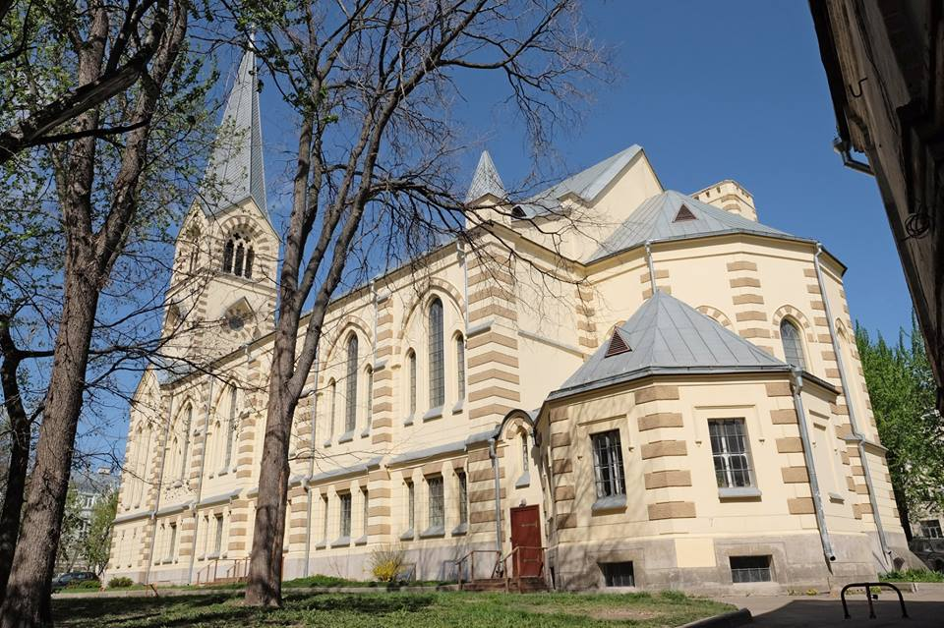

The pilgrims received an extremely warm welcome from the Cathedral’s Dean Pr Lena Bondarenko, who said that they had never been visited by such a large delegation of Anglicans before and she was thrilled to see us. She commented that she had a deep affection for Anglicans as she had spent her two year internship after completing her seminary training at the Anglican chapel in St Petersburg, there being no Lutheran vacancies she could fill in the city. This had given her a love of Anglican liturgy and practice. The Dean went on to explain about the surprising yet tragic history of Lutherans in Russia.

Lutherans were first invited to Russia by Ivan the Terrible and have therefore been in the country for over 400 years, subsequent Tsars including Peter the Great and the Empress Catherine the Great had encouraged Lutherans from Germany, Sweden and Finland (plus the Baltic states) to move into Russia wanting their expertise in trading, craftsmanship and military leadership. Lutherans were influential in the Court as many of the officials were of German descent and the Royal family often married into other European Lutheran Royal Households. Indeed Catherine the Great was initially Lutheran before converting to Orthodoxy. By 1914 there were 1,828 congregations and 3,660,000 Lutherans in Russia. The Lutheran Church achieved the official status of the second State religion (after Orthodoxy) and the Tsar himself was acknowledged as ‘Supreme Bishop’, head of the church. The Russian government supported the church through paying its higher clergy and funding its properties. In 1905 the Lutherans were allowed to celebrate the liturgy in the Russian language (as opposed to German) becoming a fully Russian Church albeit largely supported by believers of German descent. Every major Russian city had a prominent Lutheran Church in its centre.

The revolution of 1917 proved disastrous for Russian Lutherans, not only were they associated with Germans, but their close relationship with the Romanov government, and their middle case ‘merchant’ or ‘military’ status, proved a toxic combination. In 1918 all the church’s property was seized, in 1921 the church was forbidden to teach religion to anyone under 18 years of age. By 1937 the clergy had either been deported to concentration camps or executed and effectively the church’s organised structures ceased to exist. The Lutheran Cathedral was ‘repurposed’ as a cinema. Things were to get even worse. The Second World War resulted in further mass deportations of ethnic Germans to Soviet Asia or Siberia, where no religious services were permitted.

As a consequence of this severe repression, the total elimination of clergy and the deportation of ethnic Germans to remote corners of the USSR the Lutheran Evangelical church effectively ceased to exist in Russia, remaining Lutherans were driven underground. ‘Brethren’ communities were started, with a layman being elected as an elder to lead bible study and worship. These communities were unable to celebrate Holy Communion as they had no ordained Pastors, however of necessity some of the ‘lay’ brothers started to celebrate the Holy Supper. The Dean commented that this was a great spur to the ordination of women in Russia, as where there were no suitable brothers, sisters started to take on the pastoral role and even officiated at Holy Communion.

In more recent years with the fall of the Soviet Union the Lutheran Church has started to revive in Russia. It is very small in terms of numbers (around 77,000) but spread geographically over a huge area. The Dean explained that the Archbishop, The Most Rev Dietrich Brauer has his seat in the St Peter and St Paul Cathedral, his Episcopal area is divided into two – European Russia and Non- European Russia which are in turn divided in to deaneries. Whilst the church membership is predominantly of German origin around 30% of its members are ethnic Russians now.

Prior to the revolution there were two major Lutheran churches in Moscow – St Michael’s the oldest (founded 1576) served the merchant and trader class whilst the younger St Peter and St Paul church was frequented mainly by Army Officers. During the Soviet era both were turned to secular use and all religious furniture / objects removed.

The Dean explained that although the church was legally entitled to the return of its property they had to prove to the courts that they were the direct successors of the pre revolutionary owners. This wasn’t always easy and she cited a case where the Lutheran Church had been described as an ‘extremist organisation’ to block an attempt to regain ownership of their historic church building. In Moscow there were good relations with the Orthodox Church but this was not the same everywhere and sometimes the local orthodox hierarchy was not helpful to Lutherans trying to get their churches back.

The cathedral itself was extremely busy staging an organ concert at the time of our visit – the second of the day. It was refreshing to see what is a very large church full of people (including the balconies), however due to time constraints we couldn’t stay for the whole performance. The cathedral is in the process of restoration and already has a beautiful altar featuring an almost life size recreation of the last supper (carved in Riga, Latvia) and four vibrant stain glass windows illustrating St Peter, St Paul, Martin Luther and Philip Melanchthon. Somewhat unusually for Luther images he is depicted here as a priest holding a bible and a chalice (word and sacrament). The dean explained that the organ had formerly belonged to St Michael’s but had been removed by the communists and used in a crematorium before being restored for use in the Cathedral. Bizarrely the church’s clock had been taken away and installed at the KGB (now FSB) head quarters the Lubyanka where it still resides to this day.

The Cathedral also has a small chapel used for French Lutheran worship. The Dean explained that the congregation were largely Francophone African Lutherans, now living in Moscow who wanted to worship in French. She said that many of the congregation were Roman Catholics, but they were able to participate in Holy Communion together. Although fully integrated into the main congregation, this group of French speakers still liked to join together for worship in their native tongue on Thursday evenings. The Russian Lutherans receive considerable support from the German Church and the German ambassador (a licensed preacher) was coming to give a sermon at the Cathedral the following day. The President of the Federal Republic had also visited which had given great impetus to getting historic Lutheran properties returned to the Church. The Dean said that the Russian church also gets assistance from Lutherans in American Synods and she was going to visit them to strengthen their bonds. Bishop Michael explained the close ties of the Lichfield diocese with the Nord Kirche and presented the Dean with a Lichfield Cathedral guide book as a memento of our visit. The pilgrims concluded their visit with prayers in the Cathedral’s French Lutheran chapel and of course no meeting of Lutherans and Anglicans could be complete without some joyful hymn singing!!

It was encouraging to find a very active Christian community, with a full range of ministries utilising their Cathedral to great effect. On leaving the Cathedral we reflected on the strangeness of the church catholic, a group of Anglicans singing Amazing Grace, in a Russian Lutheran chapel in Moscow, founded by ethnic Germans, usually used by French speaking African Lutherans (and Catholics) - this really was an ecumenical pilgrimage!

If you are interested in joining the Anglican Lutheran Society please contact [richard739@btinternet.com](mailto:richard739@btinternet.com)