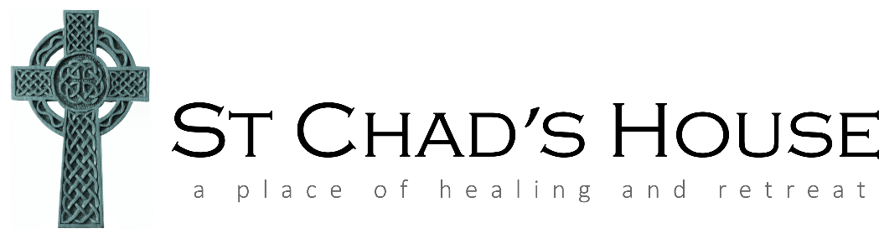

Booking form – St Chad’s House, Leek

Event name + date:

Your name:

Your phone number:

Your postal address:

Your email address:

Any dietary needs:

Any mobility needs:

Your church (if any):

Donation Given By Cash/cheque/ Bank transfer

How you heard about the day:

How you are travelling/ parking space required?

Have you visited before?

Any other information to pass on or needed for your day?

St Chad’s House, 3 Southfields, Leek, ST13 5LR email stchadsleek@gmail.com, l Tel 01538 382483. You will be contacted to confirm your place. Please do not visit St Chad’s House if you are unwell. Please follow hygiene guidance when visiting. We look forward to welcoming you to St Chad’s House.

