Profile for the appointment of an (Interim) Team Vicar for the Benefice of Brereton & Rugeley and Armitage with Handsacre

Is this you?
The Church Leader our Children and Young People would like…
Spiritual and leadership opportunities
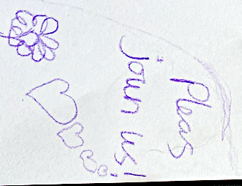
Loving
To help families and schools!
Respectful
Interactive worship with games
Listen when we talk
Caring
Believe in God
Kind
Helpful

Teach us about being a disciple of Jesus
Gentle
Help support local charities & poor people
Not just talking at us

Funny and fun to be around
Calm
Pray a lot!
Fun
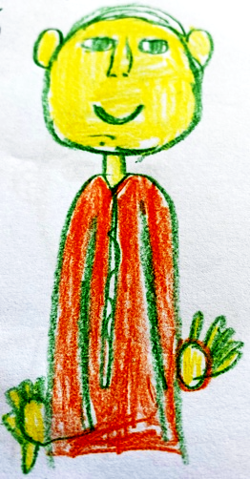
Act out stories
Someone to talk to and seek advice from
Sing fun songs to join in with

Come into our school

Involve everybody
Arrange inter-church sports events such as football matches
Church football team!

Activities to express how we feel
Table of Contents

Welcome from the Bishop of Lichfield | Page 3
Foreword from the Rural Dean | Page 4
1. Context | Page 4
2. The Challenge | Page 5
3. The Role | Page 6
4. Person specification | Page 7
5. Terms and Conditions | Page 9
6. Further Background Information | Page 10
7. The Benefice Ministry Team and Parish Teams | Page 12
8. Mission locally | Page 13
9. Worship and Activities across the Benefice | Page 14
10. The Vicarage | Page 15
11. Financial Summary for both Parishes | Page 16

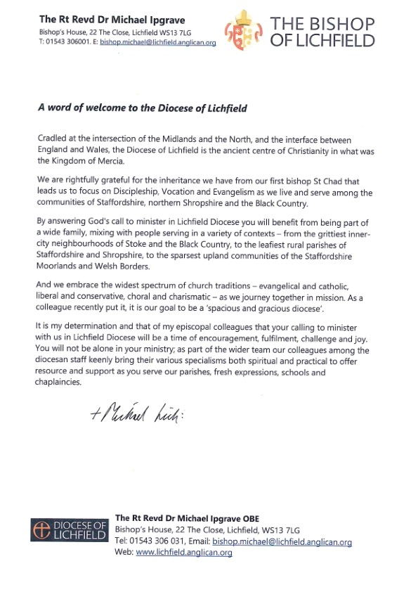

A Foreword from our Rural Dean…

" We are praying that the Holy Spirit will already be forming and calling the right person to fill this exciting post. Our Deanery mission is "growing a younger church", that is younger in attitude, openness and, yes age too! We recognise the need to build new communities, especially in the new housing areas of the benefice developing a well of confidence and trust in the church as a place of fellowship with our Lord Jesus Christ.

By choosing to answer God's call to come to the Rugeley and Brereton with Armitage benefice you will be joining a faithful, honest and warm-hearted team at a point of inflexion in the community's story. There will be plenty of scope to try new things and see where God gives his blessing. The Deanery is varied, a mix of town and "country" and a broad span of churchmanship, all devoted to God's mission in our areas, often through community engagement in its many forms. We love new ideas and look forward to supporting new ways of "being church" that a pioneer approach to mission brings."

The Revd Preb Simon C Davis

1. Context

The Parish of Armitage with Handsacre became part of an enlarged Team Ministry with the Parish of Brereton and Rugeley. The Team is served by a Team Rector and a Team Vicar (currently vacant) as well as other retired clergy and lay leaders. The combined population is around 33,250 and the electoral roll for the benefice is around 167 of whom 60 are members of St John’s Armitage.

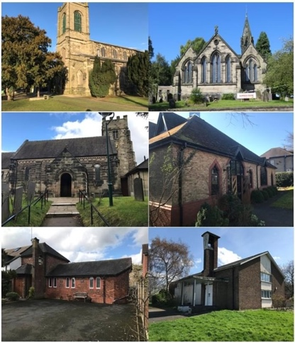
The parishes are set in an urbanised area surrounded by the beautiful mid-Staffordshire countryside of the Trent Valley and Cannock Chase. (More about the area and its wider context can be found later in this profile.)

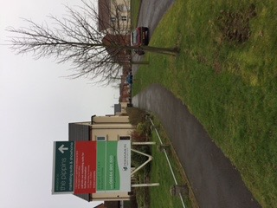
The demographic of the congregations across the Team reflects the biggest challenge. There is great potential to build on the residual and nominal faith adherence of many younger families moving into the new housing estates. The Hawksyard estate is one of many recent residential areas.
Entrance to the Hawksyard
housing development

Requests for baptisms are frequent and there is real hope that fresh expressions of church might develop through further interaction with local primary schools, of which there are two in Armitage with Handsacre and a further 9 across the benefice, growth will be possible. Three of the local primaries are Church of England linked schools, one is Roman Catholic-linked and the remainder are LEA supported. There is considerable residential development taking place in the area more generally. The recent demolition of Rugeley power station is making way for further residential expansion.

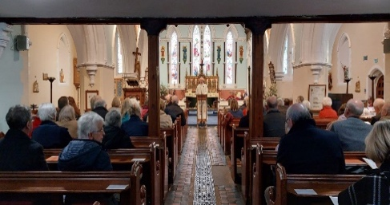
The person appointed to this post will work alongside the Team Rector in ministering across the benefice. Both parishes currently retain their own PCC and financial affairs. The person appointed will serve as a Team Vicar and become a full member of the Ministry Team working across the benefice without parish governance and buildings responsibility, although attending PCC meetings to update will be required. The shape of their ministry will be informed by the gifts and experience of whoever is appointed.

2. Challenge

Under the leadership of the Bishop of Lichfield the Diocese is renewing its vision, structures and culture. Bishop Michael expresses the invitation of our churches as “Come follow Christ, in the footsteps of St Chad.”
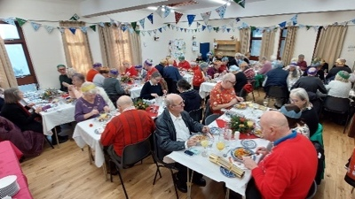
The challenges for the Team are to develop contextual mission amongst established parts of the community and in the new housing areas.

The challenge for this post is to establish a ministry within new housing estates across the benefice and build upon the blossoming relationships that have been re-established with the local schools and community groups alongside the rest of the ministry team.
3. Role
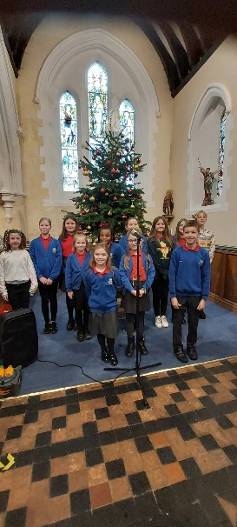
Consistent with this invitational tone and approach we are looking for a priest who is relational and energised by working with people, a person with a track record as an effective networker, who takes the initiative in pastoral care and contextual mission with enthusiasm and imagination.

In particular we seek an enabler who will work with us to:
- Provide a clear lead in evangelism and discipleship in our communities.

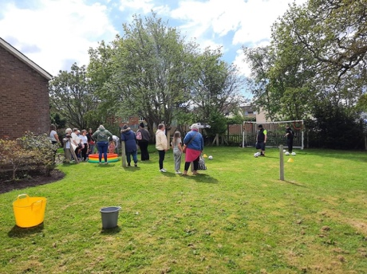
- Facilitate and develop further our relationships and pastoral care within our communities, particularly with our local families and schools, understanding and adopting an asset-based community development approach to ministry.
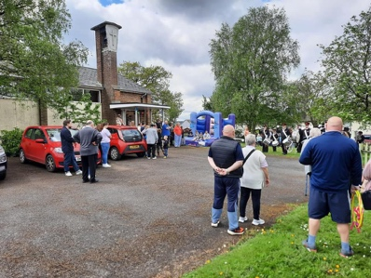
- Help to create and develop a pioneer culture for our ministries across the Ministry Team alongside the Team Rector. Taking the initiative to engage community and congregation members with pioneer/fresh expressions training and community learning networks.
- As mentioned above, the person appointed will serve as a Team Vicar and become a full member of the Ministry Team working across the benefice without parish governance and buildings responsibility, although attending PCC meetings to update will be required. The shape of their ministry will be informed by the gifts and experience of whoever is appointed.

In return we can offer you:

- A supportive and encouraging environment in which to minister, with a Team Rector who is committed to fostering, reconciling and nurturing relationships, and reflective practice within church contexts.
- Colleagues who pray together, plan together and explore new possibilities in mission and ministry together.
- Administrative support – based at St Augustine’s
- Full expenses paid
- Encouragement to take days off and holidays
- Recognition that in-service training and retreats are important
- An expectation that a realistic life/work balance is sustained
- An expanding benefice within beautiful countryside, with good schools and transport links
- An attractive, detached, modern four bedroomed house

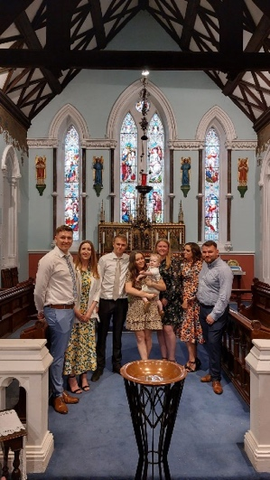

4. Person Specification

The person we are looking for to take up this ministry will have:

- A well-established prayer life to sustain them.

- Demonstrable experience in identifying and responding to contextual mission opportunities including Life Events
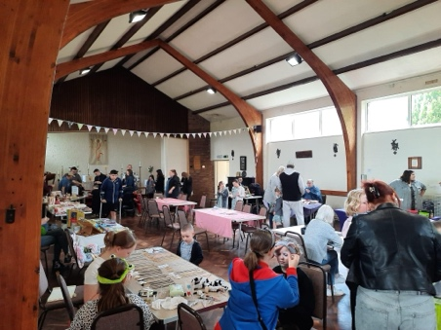
- An understanding of asset-based community development approaches within mission, especially within estates contexts

- A collaborative style with gifts of enthusing and encouraging others and developing teams

- Ability to make decisions and give direction

- Good organisational skills

- Experience of working in a local context and a wider setting and comfortable with balancing the different demands

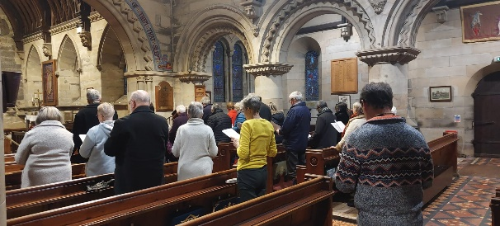
- Patience and perseverance, with an openness and commitment to listening to God and others

- Resilience, patience and perseverance, determined to wait upon God

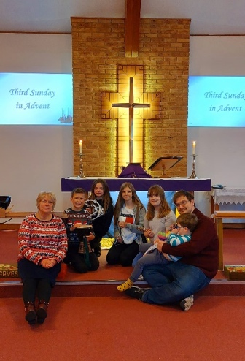
- A collaborative and co-operative personality, willing to work and live with colleagues in ministry both lay and ordained; a natural networker

- A passion for the Word of God as relevant to life today and an ability to communicate with different people and age groups

- Experience in working with schools and families

- Experience in leading worship in a variety of styles and creative in developing this across the benefice

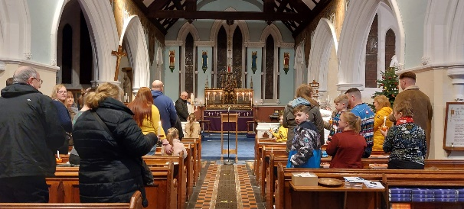
5. Terms and Conditions of this Post

This is a post offered under the general terms and conditions of Common Tenure.

The full-time nature of the post is guaranteed for the first three years after appointment, with no increased common fund requirement from the Team Parishes until 2026. During this time, it is hoped that the parishes will improve their financial position and be able to gradually take up the full responsibility of this post.

This is a serious attempt to provide resources to support a mission opportunity in the new team. The post holder will be regarded as a Team Vicar, although the appointment will be made as an interim minister under the provisions of Common Tenure to allow changes to the post to be made after 3 years when the financial position, missional opportunities, and size of the post, will be reviewed. An interview process will take place with the interim post holder being welcome to apply.

If you would like to discuss this or find out more, please contact:
The Archdeacon of Lichfield, The Ven. Dr Sue Weller, or Bishop Michael Ipgrave, Bishop of Lichfield
Email archdeacon.lichfield@lichfield.anglican.org
Tel 01543 262492
Email bishop.lichfield@lichfield.anglican.org
Tel 01543 306000

6. Further background information

The benefice is situated in an urbanised area, set in the beautiful mid Staffordshire countryside in the Trent Valley, with part of Cannock Chase (an Area of Outstanding Natural Beauty) within the benefice. 60% of the area covered by Cannock Chase District is designated Greenbelt. Originally Brereton was a farming community and Rugeley a market town, though both changed in character due to the opening, and later closing, of several local mines.

The demographic of the population is mixed in terms of age groups and household incomes, though the racial mix remains mainly Caucasian. As a former mining area, there are parts of the benefice that suffer from a moderate level of social deprivation. However, towards the edge of town (particularly near the River Trent and the Trent and Mersey Canal) and several surrounding villages, there is more affluence.
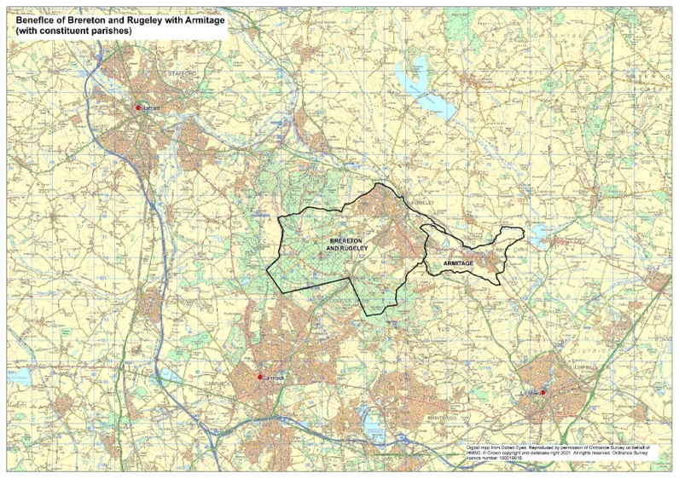
Overall, the area is generally considered a safe, pleasant place to live. The people are welcoming and friendly, and there is a good sense of community within the area.

The area has seen much change over recent years. The last coal pit in the area closed in 1990. The power station shut down in mid 2016. Established employer Armitage Shanks, now Ideal Standard, are local to the benefice.

Armitage with Handsacre is about 5 miles northwest of Lichfield in the Deanery of Rugeley and has a population of approximately 7500 in 2,700 households. A hermit is said to have lived among the rocks here before the church was built. It is likely that the name ‘Armitage’ came from ‘Hermitage’. ‘Handsacre’ is reckoned to be of Saxon origin and derived from ‘Han’s acre’.

The Trent and Mersey canal runs through the length of the benefice and close to both St Augustine’s in Rugeley and to St John’s in Armitage. The churches are often visited by people on canal holidays and who live on the canal. There is also the natural beauty of the river Trent running close by.

The Local Authority Local Plan (2014) for the District of Cannock Chase, in which Brereton and Rugeley fall, indicates plans for expansion of residential areas and also the creation of ‘high quality employment’ in the vicinity of the decommissioned power station. Five hundred of the planned 680 new homes making up the expanded residential areas have been built just over the District Council boundary in Lichfield District in which Armitage and Handsacre are located. This is the Hawksyard development and much of this housing has effectively joined the two communities of Brereton and Armitage.

The Parish of Brereton and Rugeley has existed in its current form since 2006 when Brereton and Rugeley came together served by a Team Rector. The current Team Rector was installed in February 2024 having been Team Vicar within the benefice for 18 months. Cath has a heart for collaborative ministry, reconciliation and sharing the love of Christ with all she meets. Enabling other is very much at the heart of Cath’s ministry.

Since 2017, there has been an emphasis on training up lay worship leaders and establish a direction captured in the booklet “Future Flourishing” which is available to download with the application documents. In addition the sense of unity and collaboration has been fostered through the notion that we are “one church in six places”. This is a work in progress!

7. The Benefice Ministry Team and Parish Teams

The Ministry Team serving the whole benefice is made up as follows:

Team Rector: Rev Cath Leighton
Team Vicar: Vacant
Associate Minister (OLM): Rev Brian Tabernor (non-stipendiary)
Associate Priest (Retired) Revd Margaret Brighton (Director for training)
OLM (Retired) Rev Jan Brittle
Reader: Mr Steven Hammersley
Reader: Mr Brian Syk
Reader: Mr Craig Hibbert
Reader: Mr Neil Bateman
Lay Worship Leader: Mrs Kate Cottrell
Lay Worship Leader: Mr Howard Cottrell

Other key roles:

Parish Secretary for Brereton & Rugeley: Mr Howard Cottrell
Parish Treasurer for Brereton & Rugeley: Mr David Smith (interim)

Parish Secretary For Armitage with Handsacre: Mrs Liz Coles
Parish Treasurer of St John the Baptist Church: Mr Stuart Draper

Benefice Safeguarding Co-Ordinator: Mr Stuart Draper

Benefice Administrator 20hrs/week: Miss Amy Lee

8. Mission locally

The Benefice of Brereton, Rugeley & Armitage is active in the life of our deanery (Rugeley Deanery). As such it works with colleagues and co-workers to share learning, to encourage collaboration and find solidarity together.

The Shaping for Mission process instigated by the Diocese of Lichfield in 2020, has provided positive opportunities to share priorities and open up discussions about the future development of mission in the area. One of the priorities identified in the Shaping for Mission process has been the need to build a younger church. The Covid pandemic and the slow and maybe, partial recovery from it in terms of numbers attending traditional church services, has shone a spotlight on the age demographic of our worshipping communities and the obvious lack of representation of young people, young couples and families.

As a Ministry Team, and as PCCs (Brereton & Rugeley and Armitage and Handsacre) there is wide acknowledgement that this needs to be addressed, and a growing understanding that the way these gaps will be effectively tackled will be by new forms of convening people from different age and life-stage groups around the good news of the Gospel presented and explored in new and largely untried ways. The Ministry Team and PCCs are beginning to explore what and how such new ways might look like. In the process we are anticipating a level of renewal of our vision and approach to the message of the Kingdom of God.

In Brereton and Rugeley there are 3 Church Controlled Primary Schools, 6 Community Primary Schools, and the Hart Academy providing secondary education spread over two main sites. Most of the Schools visit our Churches for special Services (Harvest, Christmas, Easter) and for support for their R.E. curriculum (topics such as ‘worship’, ‘marriage’ and ‘Baptism’). Collective Worship and assemblies are led regularly in our schools by members of the ministry team, supported by the laity.

In Armitage with Handsacre there are two maintained primary schools in the parish: Hayes Meadow in Handsacre and The Croft in Armitage (See www.ofsted,gov,uk for further information). There are renewed links with both of these schools and children are involved in Carol Services and visiting the church to support their learning.

There are secondary schools in Rugeley, Lichfield and Cannock.

The construction of large numbers of new homes and a new school on the site of the power station represents a huge opportunity for outreach and mission in the very near future.

9. Worship and Activities across the Benefice

Worship across the churches of the benefice varies in style, but is in the main liturgical and Eucharistic. Vestments are usually worn at Services. Common Worship is most frequently used across the Benefice, for the Eucharist, Morning Worship and occasional offices.

The pattern of worship for the Brereton and Rugeley churches is Holy Communion every other week with usually lay led Morning Worship on the other weeks.

Currently Armitage with Handsacre parish has 3 Holy Communion services followed by lay led Morning Worship on week 4.

Benefice services are held on week 5 in a different church each time, as well as on important dates across the church calendar. For example, benefice services took place on Mothering Sunday and Pentecost this year.

A weekly email Bulletin is produced for the whole benefice by the benefice office. This goes to some 370 subscribers. A printed copy is also produced for those not online.

Other activities within our churches are:-
- Changing Rooms - a free Counselling Service based at Church of the Holy Spirit with trained counsellors and run by Christians.
- Links to Debt advice alongside Penk MoneyWise
- Lunch Bunch - full cooked meal for the local community, aimed at those who are vulnerable in any way. Many takeaways are provided too and delivered same day. Based at St Michael’s Church, Brereton.
- Places of Welcome happen in many of our churches during the week and St John the Baptist Church, Armitage is open during daylight hours every day.
- Church Mice: A Christian based baby and toddler group at St John the Baptist, Armitage for local families.
- Craft Group is run at St Augustine’s Church, Rugeley.
- Monthly coffee morning with raffle at St John the Baptist, Slitting Mill.
- New links with the local community on the Pear Tree Estate at The Church of The Good Shepherd. A very enthusiastic community committee is currently running the Community Hall which has just reopened to the public following an appeal. A 65th Anniversary weekend with Fun Day and Thanksgiving Service at the beginning of May 2024 was very successful.

10. The Vicarage at Peakes Road, Etching Hill
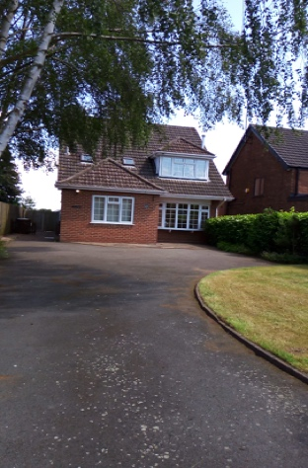
This property is a 4 bedroom detached dormer bungalow with a large drive.

The entrance door is located on the LH-side of the property and the ground floor consists of a small entrance passage with a study off to the RH-side. Through an internal door there is access to the rest of the downstairs rooms, a cloakroom with understairs storage, a large kitchen with utility room (access to the rear garden), a large lounge through to dining room. Sliding patio doors from the dining room lead into a large mainly grassed rear garden, with a sloping patio down to a garage which can be used for storage.

Upstairs, there is a bathroom with shower over the bath, with storage under the eaves in addition to the loft from the landing and 4 good-sized bedrooms.

The clergy house is within a few minutes walking distance from the Church of the Holy Spirit.
11. Finances for the Benefice

Brereton & Rugeley Parish
Finance Review
Brereton and Rugeley background from 2020: The Parish faced a very difficult financial position at the end of 2019 due to the underpayment of the Parish Share, accumulation of debt to the Board of Finance, and the continued depletion of reserves.

2020 The incumbent at St Michael’s Church left and the post was dissolved.
Parish funds at 31 December 2020 totalled £83,859 compared to £124,986 at the end of 2019. Only £30,489 of these funds are unrestricted compared with £72,136 at the end of 2019.

2021 The Charity has reviewed its cash flow forecasts and considered the impact going forward. The PCC strove to fundraise to try to cover some of the existing and future commitments.

2022 The Team Rector retired. There is a 0.5 minister, shared with Armitage and consequently links with Armitage have been much closer, with the Churches working together under the 1 church in 6 places concept.
Some churches have failed to recover their congregations after Covid resulting in the running of these churches becoming more difficult. Other churches have experienced slow growth in numbers.

2023 This year saw a slow recovery in our financial position. Despite a reduction in attendance figures, the congregations of each church managed to make a full payment to the Common Fund (£50,841) and in addition, paid off £3,000 of historical debt.
A significant legacy to St Augustine’s, helped restore their financial position and enabled necessary repairs to the building to be made.
Giving by the congregations increased by 4% in value, which given the cost of living increase, shows a commitment to supporting the church.

 | 2023 | 2022 | 2021 | 2020 | 2019
Av Sunday Attend | 75 | 103 | 77 | N/A | 146

 | 2023 | 2022 | 2021 | 2020 | 2019
Income | 187,881 | 227,117 | 155,765 | 95,064 | 147,158
Expenditure | 173,872 | 107,144 | 180,515 | 145,171 | 162,893
Giving | 94,998 | 91,311 | 117,390 | 79,225 | 102,040

Armitage with Handsacre Parish
3 Year Financial Summary to December 31st (£)

2021 2022 2023
Income and endowments from:
Donations and legacies 30,191.59 21,469.75 321,646.16
Income from charitable activities 6,701.85 5,569.76 11,077.75
Investments 4,644.67 5,491.77 6,231.83
Total income 41,538.11 32,531.28 338,955.74

Expenditure on:
Raising funds 1,358.32
Expenditure on charitable activities 28,491.77 42,976.55 52,956.13
Other expenditure 704.28 1,428.66
Total expenditure 29,196.05 44,405.21 54,314.45

Net income/(expenditure) 12,342.06 (11,873.93) 284,641.29
Net Total Assets 65,237.72 53,563.79 507,719.64

NB: A large legacy was received at the end of 2023

 | 2023 | 2022 | 2021 | 2020 | 2019
Av Sunday Attend | 30 | 25 | 25 | N/A | 61

