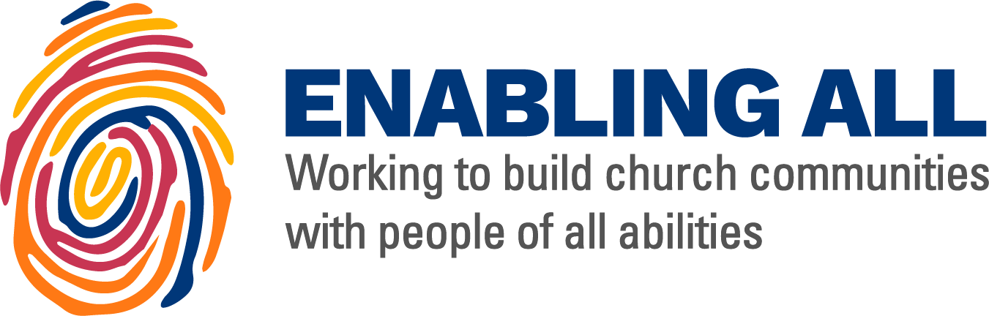

A Resource Pack for Community Projects

With thanks to the Church of Ireland Youth Department, United Dioceses of Dublin & Glendalough and the Diocese of Leeds for their collaboration.

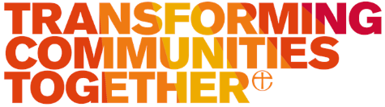

This pack is designed to help you as a community to think through some of the issues
and challenges involved in making your project and community events to be more accessible.

.

Disabled people should be able to access our community events and project, not just as visitors, but as people who may also contribute to leadership.

There are around 10 million disabled people in the UK and around 600,000 in Ireland.

Wheelchair-users are about 7.5% of all “disabled” people.

95% of people will experience a disabling condition at some time in their lives.

There are many “hidden” disabilities: for example, epilepsy, arthritis and other conditions which cause significant levels of pain, diabetes, fibromyalgia, endometriosis and mental health problems.

The Equality Act of 2010 applies to charity organisations, as a “service provider”, and as voluntary organisations, and they are required to comply with this legislation.
The Equality Act requires us to make “reasonable adjustments” to features which could be barriers to disabled people.

These posters are not exhaustive but hopefully will prompt thoughts and discussion.

This resource was made by disabled people, and in consultation with disabled people. It was born out of discussions at Disability Awareness Training between children and youth officers who have a passion for disability inclusion within the Church.
One of the keys is communication; if you have someone in your church with particular need, talk to them. It sounds obvious but doesn’t always happen.
With the best will in the world, we are only human, we sometimes get things wrong, and we are all learning together.
If you'd like to raise an issue, suggest an alteration or addition, or flag up something, please email enabling.all@lichfield.anglican.org and we'll get back to you as soon as possible.

There is no one size fits all, but there are small things we can all do to ensure that all who come feel welcome.

for those with Dyslexia

Do....

Use images and diagrams to support text.

Align text to the left and keep consistent layout.

Consider producing materials in other formats (for example audio or video).

Keep content short, clear and simple.

Use dyslexia-friendly fonts where possible (e.g. Lexie Readable, Dyslexie, Comic Sans).

Print material on light coloured paper.
Don’t....
Use large blocks of heavy text.

Underline words, use italics or write in capitals -use bold instead.

Force users to remember things from previous pages - give reminders and prompts.

Put too much information in one place.

Use text over a background image - keep the background plain.

for those who are
Hearing impaired
and/or D/deaf

Do....
Speak clearly, not loudly.

Ensure your face and mouth can be clearly
seen when speaking.

Look at people directly and speak normally.

Provide ISL/BSL interpretation if asked for it.

Use closed captioning and subtitles for videos/social media.
Don’t....
Shout or exaggerate speech.
Speak when in the dark or shadows.
Assume all hearing impaired people use sign language or can lip read.

Discard the use of microphones if you think people can hear you - microphones are often needed for the hearing loop to work properly.

for those who are
Visual impaired
Or Blind

Do...

Stand in good light.

Speak clearly but not over loudly.

Offer visual impaired people large print/braille literature and signs.

Make sure that the ground is as smooth as possible and there are no obstacles in the way.

Ensure that any steps or stairs have been marked with high-vis paint or tape so they can be clearly seen.
Don’t....
Push a person – let them take your arm.

Rely on people being able to read to learn information.

Post pictures without image descriptions.

Link to pages on website by saying “click here”
- instead make the hyperlink the name of the page.

for those with
Neurodivergence
& Cognitive Disorders

Do....
Keep services and meetings as short as possible.
Create a relaxed environment where people can make noise and move around if needed.

Reduce any intense sensory triggers
e.g. fluorescent lights, strong smells, loud noises.

Create a quiet space for people who might get overwhelmed.

Make it clear when people should sit and stand etc - don’t expect everyone to know automatically.

Use plain, not childish language with people with learning difficulties.
Don’t....
Rely too much on words and text – use images as well.

Force anyone to handshake, hug, or touch.

Be offended if people don’t make eye contact.

Hurry a speech impaired person, be relaxed and positive.

Finish people’s sentences.

for those who are

and / or have
Wheelchair Users Mobility Difficulties

Do....
Reserve your own accessible parking bays.

Sit down and converse at eye level with someone in a wheelchair.

Reserve seats with arm rests by the entrance for people who can’t walk far.

Politely ask people to sit down if they block a wheelchair user’s view.

Make sure the floor is as smooth as possible and there is plenty of room to get a wheelchair through.
Don’t....

Don’t lean on a wheelchair or move it unless the user asks you.

Rush someone with mobility problems.

Assume everyone can stand during songs/readings.

Leave heavy doors unattended if a wheelchair/crutch/cane user needs to get through.

for those with
Anxiety and Mental Illness

Do....
Make sure the main entrance, exit and toilets are signposted so that people don’t have to ask where they are.

Create an environment where people feel comfortable to get up and move around if they need to.

Keep sensory input to a minimum e.g. loud noises, bright lights.

Make adjustments if people ask for them (e.g. turning music down).

Be aware of the signs of a panic attack and how you could help.
Don’t....
Make people feel embarrassed by any behaviour that seems abnormal to you.

Draw attention to someone who appears to be in distress.

Call on people without them knowing as they may feel uncomfortable.

Be offended if someone leaves suddenly or refuses help.

for those with
Dementia

Do....
Have signage on both sides of the door e.g. a sign to the toilet and another in the toilet saying ‘this way to main church building’

Use signs with images as well as text.

Keep sensory triggers to a minimum e.g. bright lights, loud noises, strong smells.

Provide lighting that minimises big shadows.

Arrange transport for a person with dementia if necessary.

Encourage the befriending of a person with dementia with a buddy system if necessary.

Don’t....
Use dark coloured door mats if you have a light coloured floor-they can seem like a hole in the floor to someone with dementia.

Embarrass people if they make a mistake or say something that sounds silly.

Become impatient with a person if they repeat something more than once.

for those with
Asthma and
Allergies

Do....
Take allergies seriously.

Remove triggers, especially airborne triggers e.g. flowers, incense, nuts, gluten.

Make it clear if there are any allergens in foods/drinks you are providing.

Provide allergen-free alternatives if possible and keep them separate.

Make sure your first aider knows how to use an epi-pen.

Know the signs of an asthma attack/allergic reaction, how to help and when to call emergency services.
Don’t....
Dismiss someone’s allergies as “not serious”.

Prioritise traditions over someone’s health and accessibility.

Demand someone participate in a physical task.

for those with

Chronic Pain/
Chronic Illness

Do.... Don’t....

Provide plenty of seating, especially seating with cushions/padding.

Make it clear that people can remain seated or move around if they need to.

Make sure you building is warm but not too hot -around 22c is optimal.
Expect everyone to be able to do what seems to you a simple task.

Dismiss people's experiences because their condition is invisible.

Force people to move around more than necessary.

A Welcoming Church for All General Tips on What to Do

Speak directly to the person - don’t use a go- between.

Offer to help, but don’t be offended by refusal, and don’t help without asking.

Some people with hidden disabilities may need assistance.

Use positive terms e.g. ‘disabled people’ not ‘the disabled’.

Ensure people know where the toilets are and don’t have to ask.

Give eye contact, whether or not returned, but don’t stare.

Be patient – some people take longer to respond than others.

Enable disabled people to sit where and with whom they wish.

Give help discreetly- don’t make the person feel conspicuous.

Introduce yourself clearly by name when meeting someone new

