**Share a prayer through dementia**

**Bishop Michael writes:**

**“**Prayer is the first response of the human being to the God who has created and loves us, and it can be the last response too. Words may be forgotten, memories fail, thoughts be confused, but the Spirit always comes to us in our weakness to help us to pray. Dementia is no bar to our praying; rather, it is a place from which and through which we can pray from the heart.**”**

**The Rt Revd Dr Michael Ipgrave OBE, 99th Bishop of Lichfield**

**What?** You are invited to write and share your own prayer through dementia. What’s the prayer you are able to pray from the heart, for yourself or for others who are affected by dementia?

* Perhaps you have lived experience of dementia and it is your own prayer.
* Perhaps it is a prayer for someone with a diagnosis of dementia.
* Or perhaps it is a prayer for a carer.
* Your prayer may even be one to use at a funeral of someone who had dementia.

**When? Prayers can be shared at any time.**

**How? Simply send your prayer to Sarah Thorpe, Dementia-Friendly Church Enabler,**

**Diocese of Lichfield at** [sarah.thorpe@lichfield.anglican.org](mailto:sarah.thorpe@lichfield.anglican.org) **or 0798 224 8949**

**Psalms…The heartfelt words of the Psalms can inspire our prayers.**

**These words are from Psalm 61 verses 1-4:**

“Hear my cry, O God; listen to my prayer.  
From the end of the earth I call to you, when my heart is faint.

Lead me to the rock that is higher than I,  
for you are my refuge, a strong tower against the enemy.

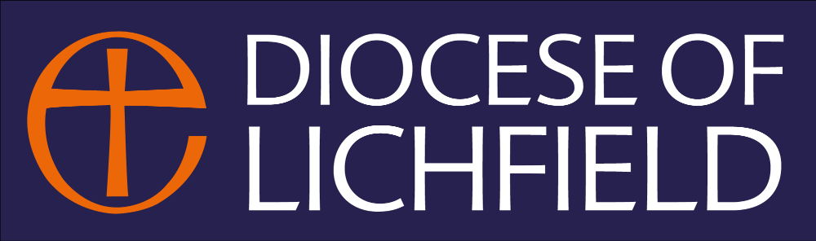Let me abide in your tent forever, find refuge under the shelter of your wings.”