Dementia-Friendly Schools -Physical Environment Checklist

Clive Rogers comes to Bomere Heath CE Primary School

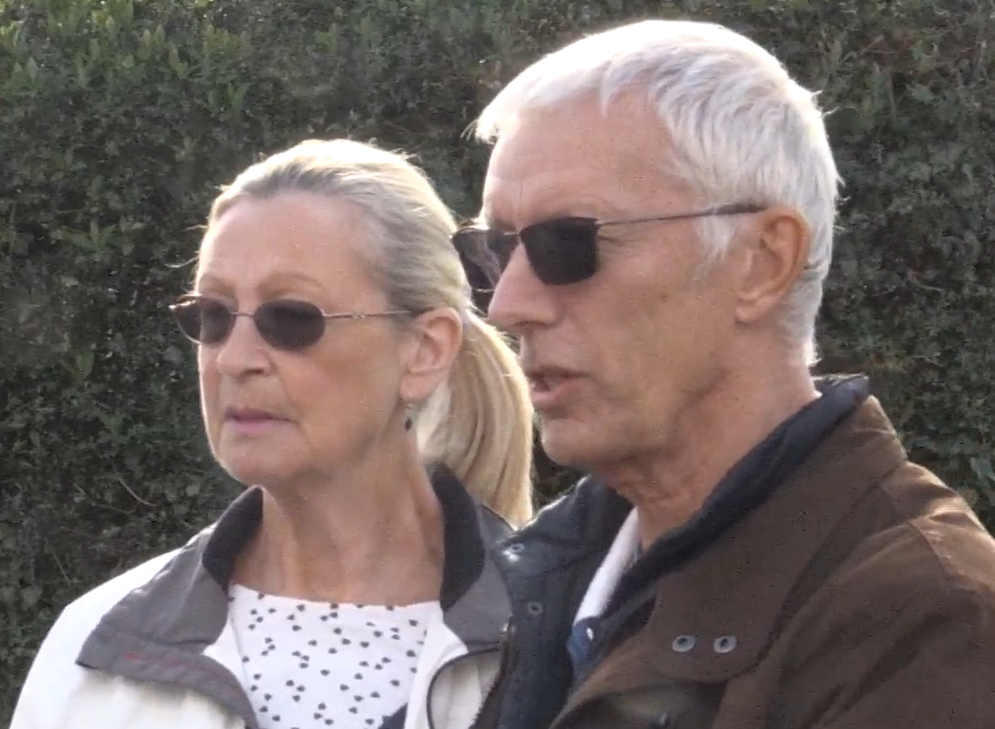

This Checklist accompanies the 10-minute film in which Clive and Barbara Rogers go round Bomere Heath CE Primary School in Shropshire: [add link to film]. Clive used to be a Flight Lieutenant in the RAF; he was diagnosed with mixed dementia in 2017 – Alzheimer’s Disease, frontotemporal dementia and vascular dementia. As Clive and Barbara go round the school, Clive explains what’s helpful and what’s difficult. You can read more about Clive and Barbara Rogers’ story here: Making the days count: After a dementia diagnosis, a Shrewsbury couple share their story | Shropshire Star

After watching the film, use this checklist to review your own school for dementia-friendliness.
What’s the impact?  Clive’s reflections and some suggestions | Notes from reviewing our own school

Signage
Is the main entrance to school clearly signed, as you arrive, with a clear sign on or above the door?
On noticeboards and signage, good colour contrast is important.
If there’s a push button for opening a door, ideally it should be right beside the door. It’s really helpful if it’s marked clearly with a nice, bright big sign to make it stand out.
Inside school can be helpful to add simple laminated signs, with arrows and/or pictures as necessary, to navigate round the building e.g. to indicate the way to the toilet or where there is hot/boiling water.
- Black writing on a yellow background is clear.
- Also, although not covered in the film, on the toilet door itself, it is helpful to have a sign with words and pictures.
- Further, although not covered in the film, signs showing the way to the exit door can be helpful.

Screen sign in

This may be difficult for someone with dementia. Some people with dementia cannot use a screen at all.
- It’s helpful if there’s someone who can give a personal welcome and type in the information, if needed.
- If there’s a lot of text to read, that may be difficult. Here too, it’s helpful if someone can talk through the essential information.

Notices and noticeboards
Although not specifically discussed in the film:
- It helps if the notices / noticeboards / screens are at eye level: if you have to look upwards, it’s easy to lose balance.
- It’s helpful if the notices / noticeboards / screens are not too busy/cluttered.

Flooring and mats
Some colours of carpet can be tricky. A plain neutral colour is helpful.
- Checkered or patterned floors/tiles can be difficult: busy floors are not good. They can impact balance.
- A black mat or black flooring is difficult: it can look like a hole.
- Herringbone wasn’t ideal.
- Also, although not covered in the film, a shiny floor surface can be difficult: it can look like water.

Steps
Shadows and half light can be difficult: poor lighting can impact on peripheral vision and balance.
- Yellow and black tape or a colour contrast can help to mark the edge of a step clearly. This helps to judge the depth.
- A handrail is helpful, for steps: although a low handrail may help the children, people with dementia will need a handrail to be at the right height for adults.

Lighting
Shadows and half light can be difficult: poor lighting can impact on peripheral vision and balance.
- Good clear lighting makes a real difference.

Seating
- Cushioned or padded seating can be helpful, for chairs.
- The height of the chairs makes a difference, too – not too low.
- Also, although not covered in film, it can be helpful to have arms on chairs, to help with getting up.

Toilet
It’s helpful if the fittings are in plain constrasting colours so that they are clearly visible.
- It’s helpful if the toilet seat is a contrasting colour to the walls and the rest of the toilet.
- Hand holds are helpful.

Changes to make the school environment more dementia-friendly can be helpful to others, too – both children and their famililes.

For some issues that are unhelpful for dementia-friendliness, there is a simple, cost-effective solution e.g. adding laminated signs. Here, it’s good to go ahead and make straightforward changes. It’s also important to communicate why we’re doing so. As we name and face dementia together, we increase awareness and we open up connections and conversations: that’s all part of becoming a more dementia-friendly school.

We may identify other issues which are not a “quick fix”, perhaps because they would require significant expenditure e.g. changing flooring or upgrading lighting. Here, we might add the change to the “wish list” for the next refurbishment. We can also share our understanding and offer support e.g. a offering a steadying hand when walking over a checkered floor.

More about Dementia-Friendly Physical Environment
- Alzheimer’s Society “Dementia-friendly environment checklist”: https://www.alzheimers.org.uk/get-involved/dementia-friendly-resources/organisations/dementia-friendly-environment-checklist
- DSDC, Stirling University: The Dementia Services Development Centre at Stirling University Dementia Services Development Centre (stir.ac.uk) includes research / information / resources on a dementia-friendly physical environment.
- The dementia environment at home: For more about a dementia-friendly physical environment at home, here’s a helpful 12 minute video.

More about our Dementia-Friendly Churches and Schools Network
The Dementia-Friendly Churches and Schools network in the Diocese of Lichfield brings together communities across Staffordshire, The Black Country and north Shropshire. We work together to increase understanding about dementia, listening to its impact and learning from one another as we stay in step with people living with dementia. We are glad to journey together, becoming more dementia-friendly.
Dementia-Friendly Churches https://www.lichfield.anglican.org/inclusion/dementia-friendly-church/

Dementia-Friendly Schools
https://www.ldbe.co.uk/becoming-dementia-friendly-schools/

For more information contact
Sarah Thorpe, Dementia-Friendly Church Enabler, Diocese of Lichfield
E: sarah.thorpe@lichfield.anglican.org
T: 07982 248949




