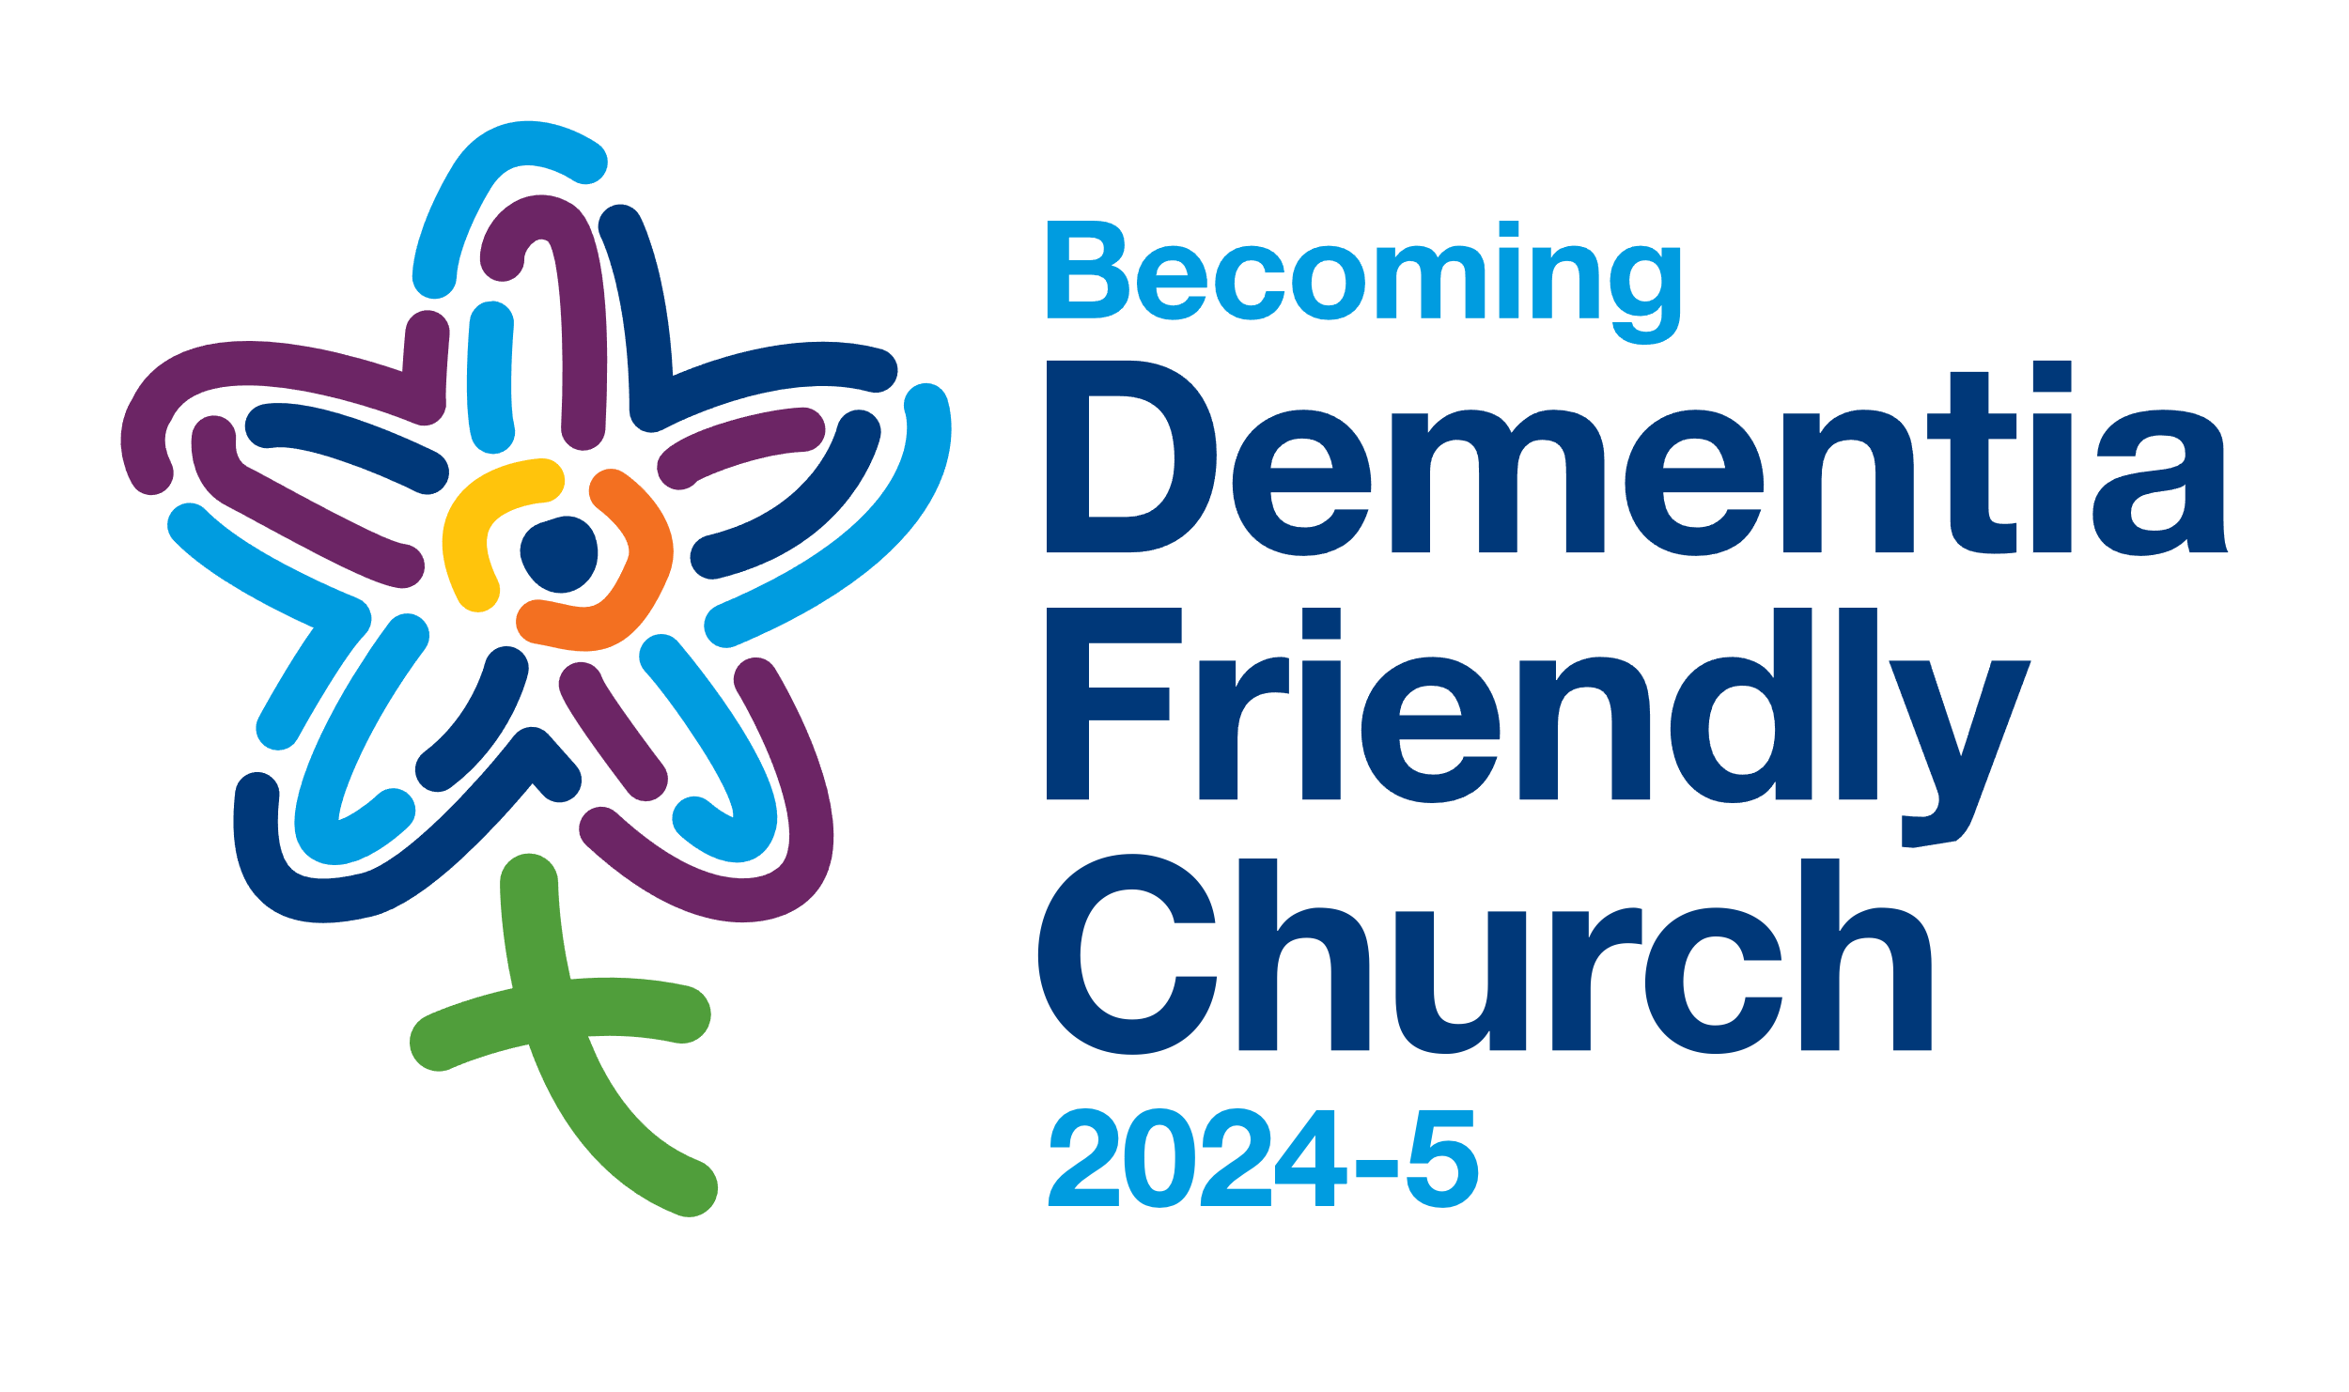

**Welcoming, Connecting, Friendly**

**Sunday worship with a dementia focus**

Dementia is part of every community, including our own church and community. Perhaps you’ve got lived experience of dementia personally, or with family, friends or neighbours.

As we become more dementia-friendly churches, we’re learning together what helps us to be more welcoming, connecting and friendly. It’s a journey we are on together, as a church family. This is an opportunity to share dementia awareness, with a practical focus on how we stay in step with one another as patterns change.

# Dementia Information

* Dementia is an umbrella term for diseases of the brain.
* The most common of those diseases are Alzheimer’s Disease and Vascular Dementia.
* Dementia is not a natural part of ageing.
* About one million people in this country have dementia.
* Dementia is one of the most feared health conditions.
* Understanding and support help us keep in step as dementia progresses.

# Stages of Dementia

#### Drawn from Dementia UK website <https://www.dementiauk.org/information-and-support/about-dementia/stages-of-dementia/>

**MIDDLE STAGE**

**LATE**

**STAGE**

**EARLY STAGE**

Signs and symptoms become more obvious and will have a bigger impact on daily life.

Starting to experience problems affecting everyday living - perhaps noticed by the person themselves or perhaps first recognised by family, friends or colleagues.

Changes become more pronounced so that the person may be unable to live independently - and may need a care package in place or long-term residential care.

# Bible Reading:

# 1 John 4 verses 7 & 16-21

7Beloved, let us love one another, because love is from God; everyone who loves is born of God and knows God. … 16So we have known and believe the love that God has for us. God is love, and those who abide in love abide in God, and God abides in them. 17Love has been perfected among us in this: that we may have boldness on the day of judgment, because as he is, so are we in this world. 18There is no fear in love, but perfect love casts out fear; for fear has to do with punishment, and whoever fears has not reached perfection in love. 19We love because he first loved us. 20Those who say, “I love God,” and hate their brothers or sisters, are liars; for those who do not love a brother or sister whom they have seen, cannot love God whom they have not seen. 21The commandment we have from him is this: those who love God must love their brothers and sisters also.

# Prayer

Compassionate God,

Lead us through fear

to your love which is deeper.

Bring us to the place where we connect

with one another and with you in love. Amen

### About our Dementia-Friendly Churches and Schools Network

Lichfield Diocese’s Dementia-friendly Churches and Schools network brings together communities across Staffordshire, The Black Country and north Shropshire, increasing understanding about dementia, listening to its impact and committing to stay in step with those living with dementia. Over 100 churches are committed to take action, becoming more dementia-friendly.

For more information:

Dementia-Friendly Churches: <https://www.lichfield.anglican.org/inclusion/dementia-friendly-church/>

Dementia-Friendly Schools: <https://www.ldbe.co.uk/becoming-dementia-friendly-schools/>

or contact our Dementia-Friendly Church Enabler, Sarah Thorpe, on [sarah.thorpe@lichfield.anglican.org](mailto:sarah.thorpe@lichfield.anglican.org) or 0798 224 8949

# Three Rules

# from ‘Contented Dementia’ by Oliver James

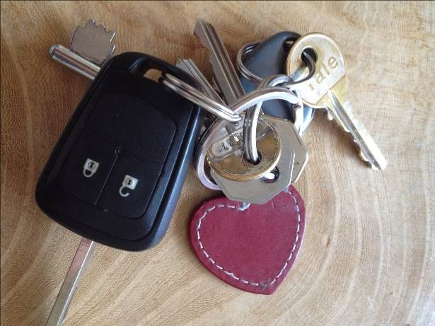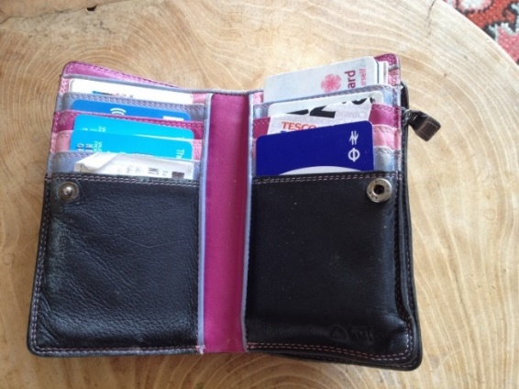

Reframe questions

# Putting it into practice: adapting our approach

|  |  |  |
| --- | --- | --- |
| When? | Instead of… | What about… |
| Someone arriving at church | How are you today? |  |
| At the end of the service | Would you like a cup of tea or coffee? |  |
| Chatting over coffee | Have you had a busy weekend? |  |

I’ve learned that people will forget what you said, people will forget what you did, but people will never forget how you made them feel.

# Prayer

**God of all,**

**Bless all our churches**

**as places of welcome and hospitality,**

**places of compassion and safety,**

**places of connection and love for all.**

**Bless us to share small acts of love,**

**freely given to others,**

**so that Christ may be made known**

**in our community.**

**Bless us to walk together as friends,**

**recognising that God journeys with us**

**as we turn our understanding into action**

**and live with hope in our hearts.**

**Amen**

