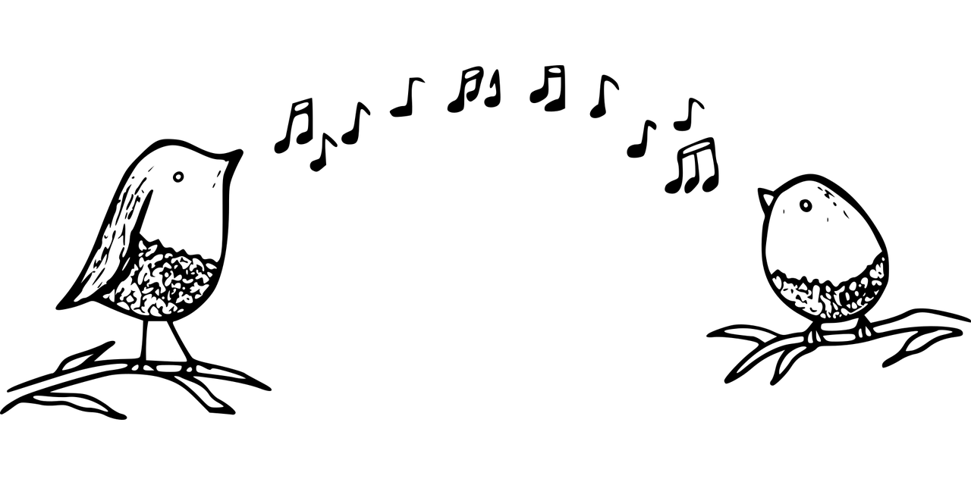
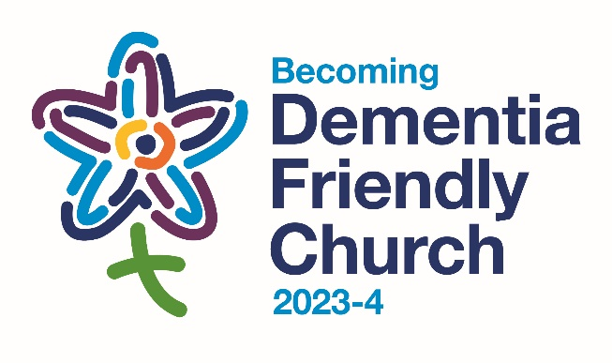

Image by Please support me! Thank you! from Pixabay

Singing from the Heart

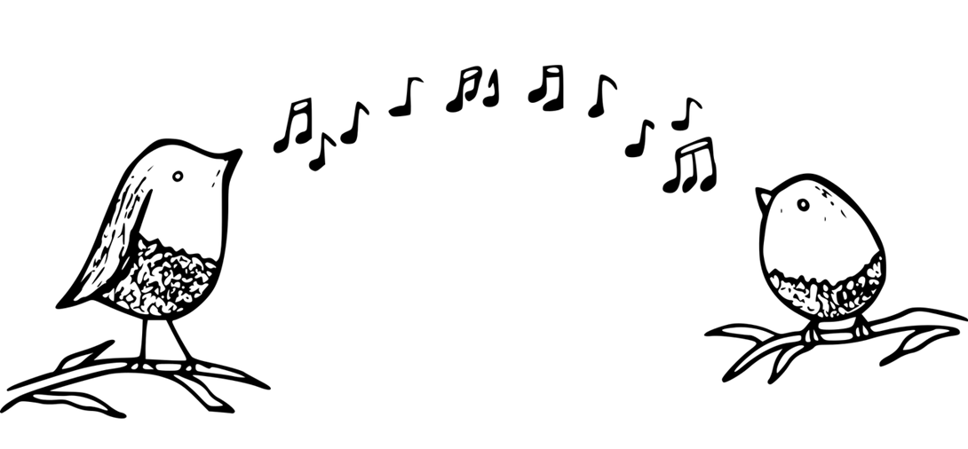
What’s your favourite song?
Opening Prayer

God of life,
As we still our bodies, slow our breathing
And open ourselves to you,
quieten our minds and hearts.
Connect us with the heartbeat
of your creative song,
touch us with the music of your presence
and connect us together in harmony. Amen

What’s your favourite song?

I wonder whether you’ve got a favourite song, one that you love to return to – a song that speaks to your heart. For some of us, it may be a hymn. For others, it may be a song that we share with a special person or that connects us with a special place or on a special occasion. Let’s spend a minute or two discussing our favourite songs – and then we’ll share the names of some of our favourites.
Photo by Michael Maasen from Unsplash
Times to sing our song

Our own favourite songs connect very deeply with our own heart and soul. In good times, our songs can be expressions of creativity and joy, expressions of life and love.
And through tough times, our songs can express our deepest longings helping us to keep hope alive - just as Spirituals have done for people through times of oppression and hardship.
Song

Our first song is the song of our Forget-me-not group here in St Andrew’s Church. Every time we meet, we sing the first verse and the chorus: it affirms that none of us has to go it alone, that we belong together. The second verse has been written specially for today’s service.

Bind us together, Lord, bind us together
with cords that cannot be broken;
bind us together, Lord, bind us together, Lord,
bind us together in love.

We are all in one boat
afloat in God’s ocean of love,
knowing that we’re not alone
as we weather the storms of life.

Bind us together, Lord, bind us together
with cords that cannot be broken;
bind us together, Lord, bind us together, Lord,
bind us together in love.

We are singing one song,
singing in harmony,
knowing that we’re not alone,
connecting together in song.

Bind us together, Lord, bind us together
with cords that cannot be broken;
bind us together, Lord, bind us together, Lord,
bind us together in love. “Bind us together”
chorus by Bob Gillman © Thankyou Music
Reading

C.S. Lewis wrote the “Chronicles of Narnia” in the 1950s, with strong Christian connections. In “The Magician’s Nephew”, Narnia is created through Aslan’s singing. Digory is the boy who hears and sees this. We can imagine this as a picture of God creating the universe, through song.
“In the darkness, something was happening at last. A voice had begun to sing. It was very far away and Digory found it hard to decide from what direction it was coming. Sometimes it seemed to come from all directions at once. Sometimes he almost thought it was coming out of the earth beneath them. Its lower notes were deep enough to be the voice of the earth herself. There were no words. There was hardly even a tune. But it was, beyond comparison, the most beautiful noise he had ever heard. It was so beautiful he could hardly bear it . . .

Then two wonders happened at the same moment. One was that the voice was suddenly joined by other voices; more voices than you could possibly count. They were in harmony with it, but far higher up the scale; cold, tingling, silvery voices. The second wonder was that the blackness overhead, all at once, was blazing with stars. They didn't come out gently one by one as on a summer evening. One moment there had been nothing but darkness; next moment a thousand, thousand points of light leaped out . . .

If you had seen and heard it, as Digory did, you would have felt quite certain that it was the First Voice, the deep one, which had made them appear and made them sing.”
C.S. Lewis, The Magician's Nephew (New York: Collier), pp. 98-9
When we recognise the beauty of creation,
we can also feel very aware of all that is all that is
disordered in our own lives and in or world.

Prayers of Longing

We recognise all that is tough and unresolved, individually and globally, and we bring this to God in our prayers.

God of life,
We bring to you all that challenges us,
the places where we are over-stretched,
or knocked out of shape
and we ask you to lead us
from discord to harmony.
Sing to the Lord a new song
Sing to the Lord all the earth *

We bring to God all that distorts our world,
the unsustainable levels of exploitation and greed
and all that is out of balance,
and we ask you to lead us
from discord to harmony.
Sing to the Lord a new song
Sing to the Lord all the earth *

* Psalm 96 verse 1
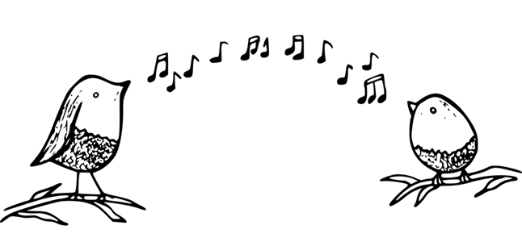
To round off our prayers of longing, we’re going to hear Paul Robeson singing “Deep River”, expressing a longing for peace and freedom – both in the present and in the future.
In this song, we acknowledge all that feels deep water in our own lives, connecting with our deepest longings and hopes. As we listen, we can join in with the singing if we wish.
Deep River
Deep river, my home is over Jordan.
Deep river, Lord, I want to cross
over into campground.
Deep river, my home is over Jordan.
Deep river, Lord, I want to cross
over into campground.
Oh, don't you want to go to the gospel feast,
That promised land where all is peace?
Oh, deep river, Lord, I want to cross
over into campground.

Bible Reading

Our Bible reading is from Isaiah Chapter 55 verse 12. It paints a picture of a restored balance and harmony, with all creation singing praise to God.

“Yes, you will go out with joy and be led forth with peace. The mountains and the hills will break forth before you singing, and all the trees of the field will clap their hands!”

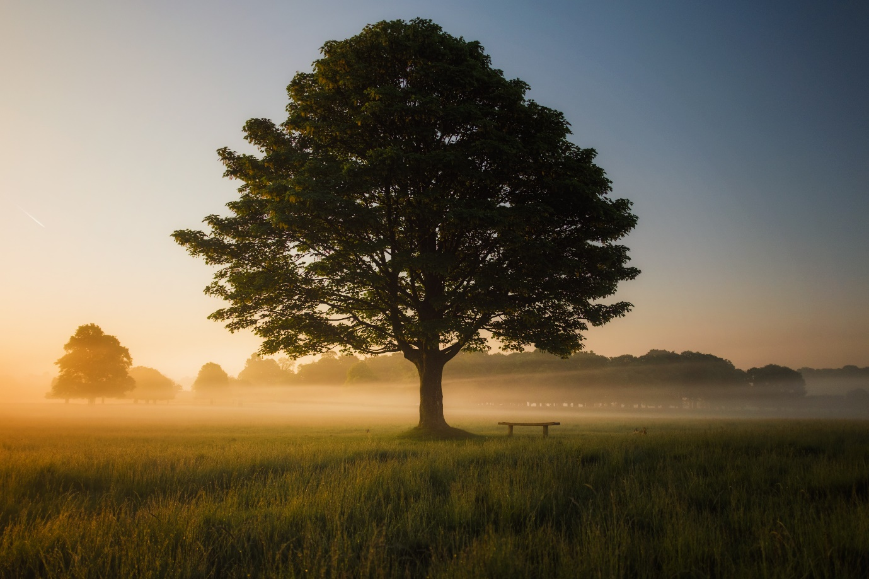Photo by Simon Wilkes on Unsplash

Prayers of Thankfulness

We recognise all that sings its song of glory to God,
in our own lives and in the whole of creation,
and we bring this to God in our prayers.

God of life,
We bring to you in thankfulness
our own true selves
and all that delights us,
all that connects us with life and laughter,
all that brings connection and community.
You shall go out with joy
And be led forth with peace *

We bring to you in thankfulness
all that weaves together sustainable life on our planet,
recognising the gift and wonder of life,
woven into a pattern that is so much bigger than us,
a flow of life that embraces earth and heaven.
You shall go out with joy
And be led forth with peace *
Amen

* Isaiah 55 verse 12
To round off our prayers of thankfulness,
we’re going to hear the song “You shall go out with joy”.
As we listen, we can join in with the singing if we wish –
and clap our hands too.

You shall go out with joy

You shall go out with joy
and be led forth with peace.
The mountains and the hills
will break forth before you.
There’ll be shouts of joy
and all the trees of the field
will clap, will clap their hands.

And all the trees of the field will clap their hands
the trees of the field will clap their hands
the trees of the field will clap their hands
while you go out with joy.

“Sunshine Songs” singalong
playing our Forget-me-not instruments
Final prayers

These next two prayers are written by members of our Forget-me-not group and are Dementia Action Week prayers for the Diocese of Lichfield.

Lord, as doubt and the perplexity of daily life
become even more confusing and uncertain,
thank you for being always present
and gently guiding and protecting me.
Thank you for family and friends who continue
to love, support and encourage me
without judgement or disdain.
I pray that I may always be aware
of your loving, guiding presence in this life
and that I will come to meet with you in the next. Amen
by Ann Shephard
God of the heart and of mind,
you know us completely;
though memory fades your spirit dwells within us.
You are present in the glimpses of hope, and
with us in the joy and uncertainty of new seasons.
In the sadness and the loss your steadfast love enfolds us;
your faithfulness endures 'til journey's end
where you have prepared a place for us.
Give us your peace and help us grow
in your likeness each and every day
through the grace of your Son our Saviour,
Jesus Christ our Lord. Amen by Di Holt
Our Father, which art in heaven, hallowed be thy name.
Thy kingdom come, thy will be done,
on earth as it is in heaven.
Give us this day our daily bread and forgive us our trespasses
as we forgive those who trespass against us.
Lead us not into temptation but deliver us from evil
for thine is the kingdom the power and the glory
for ever and ever. Amen

Final hymn
For the beauty of the earth,
for the beauty of the skies,
for the love which from our birth
over and around us lies,
Lord of all, to you we raise
this our joyful hymn of praise.

For the wonder of each hour
of the day and of the night,
hill and vale and tree and flower,
sun and moon and stars of light,
Lord of all, to you we raise
this our joyful hymn of praise.

For the joy of human love,
brother, sister, parent, child,
friends on earth and friends above,
for all gentle thoughts and mild,
Lord of all, to you we raise
this our joyful hymn of praise.

For each perfect gift of thine
to the world so freely given,
graces human and divine,
flowers of earth and buds of heaven,
Lord of all, to you we raise
this our joyful hymn of praise.

