

Archdeaconry of

## My promise as a Churchwarden

I having been duly appointed and chosen Churchwarden of the Church of

in the

Parish of

do solemnly and sincerely declare that I will faithfully and diligently perform the duties of the office of Churchwarden for the year ensuing.

**Churchwarden**

Heavenly Father, we thank you for calling us to this office and duty in the life of our congregation and parish.

Help us to remember your work of grace in us and by your Holy Spirit empower us to serve you and one another.

In the name of Jesus Christ our Lord. Amen.

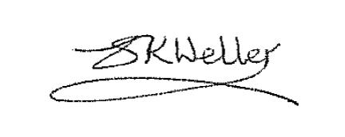

The Ven Dr Sue Weller

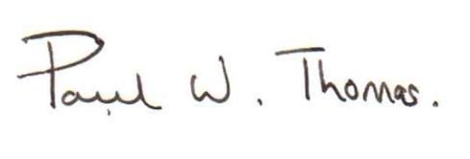 *Archdeacon of Lichfield* [archdeacon.lichfield@lichfield.anglican.org](mailto:archdeacon.lichfield@lichfield.anglican.org)

The Ven Paul Thomas

*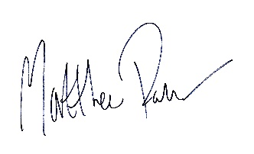 Archdeacon of Salop* [archdeacon.salop@lichfield.anglican.org](mailto:archdeacon.salop@lichfield.anglican.org)

The Ven Matthew Parker

*Archdeacon of Stoke* [archdeacon.stoke@lichfield.anglican.org](mailto:archdeacon.stoke@lichfield.anglican.org)

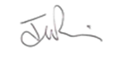

The Ven Julian Francis

*Archdeacon of Walsall* [archdeacon.walsall@lichfield.anglican.org](mailto:archdeacon.walsall@lichfield.anglican.org)

October 2020