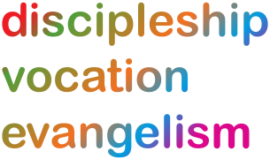
Lichfield Diocese Prayer Diary: Issue 15

During these weeks the prayer diary reflects the challenges of facing Coronavirus with our sisters and brothers across the world; the call to be a people of hope.

Sunday 12th July: CHURCHES: As churches begin to re-open for public worship pray for safety and good procedures and also for all who through age or vulnerability will continue to worship at home. We pray for our Cathedral and for the Dean, the Very Revd Adrian Dorber as he, with the Chapter and the management team respond to added pressures as a result of the pandemic. May the daily times when the Cathedral is open for private prayer be blessed and the return of the 10.30am Eucharist next Sunday be joyful and uplifting.

Mon 13th: COMMUNITIES: Transforming Communities Together give thanks for funding from the National Lottery, which is enabling them to launch #BringingPeopleTogether over the next few weeks in the Black Country, Staffordshire and Northern Shropshire. Pray for this network in these early stages as it seeks to connect people to others from the comfort of their own home and to build up community in contexts of fear, loneliness and isolation.

Tues 14th: John Keble, Priest, Tractarian, Poet, 1866 SCHOOLS: God, we pray for all of those pupils in our schools who are in a time of transition. We pray specifically for any year 4s, 6s, 8s, 11s and year 13s who are moving on.
May they leave their schools carrying with them every blessing they have received there;
blessings of friendship, blessings of memories and blessings of knowledge.
As they begin a new journey at this uncertain time may they go with the certainty of your love.
We pray also for opportunities to celebrate what has been and to say their goodbyes well,
and for school staff working hard to support their pupils in this challenging time of change. Amen

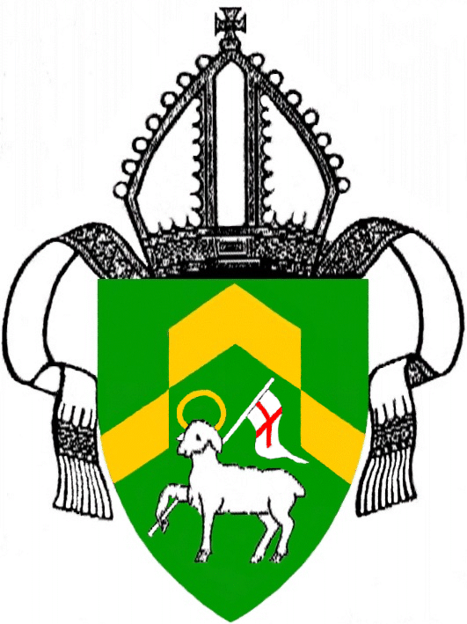
Wed 15th: Swithun, Bishop of Winchester, c.862 Bonaventure, Friar, Bishop, Teacher of the Faith, 1274 AROUND THE WORLD: As rates of infection of Covid-19 continue to accelerate throughout South Africa, we pray for Archbishop Thabo Makgoba and the Province of Southern Africa, and specifically for Bishop Steve Diseko and our companion Diocese of Matlosane. Bishop Steve shares: ‘The virus is now with is and I know of many people who are infected and those who have died’. May Bishop Steve know your guidance as he leads the Diocese; be with clergy and all offering pastoral support to the sick and bereaved and equip all health workers seeking to support those with Coronavirus.
Thur 16th: Osmund, Bishop of Salisbury, 1099 PRISONS: We pray for prisoners and staff in our prison communities who have become unwell due to COVID-19, that they might know healing; that staff might know resilience and energy following this prolonged period of intensely demanding service; for prisoners in their continuing loneliness and isolation; for prisoners wrestling with having lost a family member that they may be able to grieve safely. We pray this week particularly for Rev’d David Farley and the rest of the team at HMP Stoke Heath, and for Rev’d Jeffrey Cuttell & Rev’d David Howard and the rest of their team at HMYOI Werrington.
Fri 17th: HEALTHCARE: For all working in healthcare services at the present time, especially those on the front line caring for patients and their families; for those having to make difficult decisions or redesign services to meet a constantly changing need. For everyone as they balance their work with personal and family needs. In particular we pray for the Walsall Healthcare NHS Trust remembering Revds Alison Coles, Keith Duckett and Anthony Swaby in their chaplaincy roles, and for the Shrewsbury and Telford NHS Trust and chaplains Revds Petro Hryziuk and Mervyn Williams.

Sat 18th: Elizabeth Ferard, first Deaconess of the Church of England, Founder of the Community of St Andrew, 1883 AROUND THE WORLD: On the third anniversary of receiving confirmation that he was to become Bishop of Kuching, we join with The Rt Revd Danald Jute who asks for our prayers: ‘I humbly ask you to pray for me, for heavy are the responsibilities and weighty is the task of a bishop. ‘O God, thy sea is so great and my boat is so small’. Please help me to serve you and your people, dear Lord! Amen’. For further resources for praying for the world wide church see the Anglican Cycle of prayer: https://bit.ly/3anQUWG

