Lichfield Cathedral
Live Streaming Introduction – January 2021
As from Saturday 11 July 2020 we began live streaming our Daily Eucharist/ Morning and Evening Prayer via Switcher Studio software. These notes are intended to be of interest to those who are considering the use of the Switcher Studio app.
Switcher Studio
Switcher is an app that utilises devices with the iOS 13 or newer operating system
- iPhone: 6s and newer
- iPad: 5th generation and newer; iPad Air: 2nd generation and newer; iPad Mini: 4th generation and newer;
- iPad Pro: 9.7”, 10.2", 10.5”, 11”, 12.9”
- iPod Touch: 7th Generation.

The Switcher Studio App will need to be downloaded to each IOS device but you only need one subscription.

It also has the ability to screen share from a PC to display images or text, including subtitles. The Switcher Studio website has the software to download to your PC to allow you to share this laptop wirelessly to your iPad. It will effectively be a screenshare. We use a PowerPoint slideshow to put up subtitles via a split screen facility in Switcher Studio.

It will take up to nine input devices and is operated from an iPad.

We pay for a monthly subscription to Switcher to use the software. To schedule to Youtube or Facebook we have the Standard Subscription $75 pcm. The schedule can be set up from a PC by logging in to Switcher Dashboard on the internet. Links to the scheduled stream can then be copied and embedded on Website etc.

The app works as a live TV editing suite. It controls the input devices which are all connected via WiFi to the main iPad control device.
Audio is brought in via the Lightning connection (on an iPad Pro this is a USB-C connector) through an audio interface. Having begun with an iRig device we soon moved to Focusrite Scarlett 2i2 3rd Gen USB Audio Interface. The audio could be a single microphone or a feed from the Cathedral PA or other audio source via conventional connections.
The Switcher Studio app provides professional type settings which allow some ability to zoom in and out on the cameras and set up bespoke graphic overlays. Using a connected laptop set up as a screen sharing device subtitles can be displayed via PowerPoint in split screen mode.

The following link takes you to the website to review all the product features:
https://www.switcherstudio.com/

There are lots of YouTube video tutorials to help with getting to grips with the software and to take those who are interested into some of the more involved features of the app. These tutorials are highly recommended. The help features and customer support from Switcher Studio is also excellent.

Switcher Studio Dashboard.

In terms of initial set up you will need to link you your Facebook and/or YouTube account in Switcher Studio. This should be a one off set up, but you will need administrator access and passwords to your church accounts.

You will also be able to access any videos that have been live streamed from this Dashboard on your PC. You can share from here any past videos.

You can also access support from Switcher Studio from here too.

There are also other features that can be accessed and set up from here including video chat – bringing in someone from outside the building into your live stream.

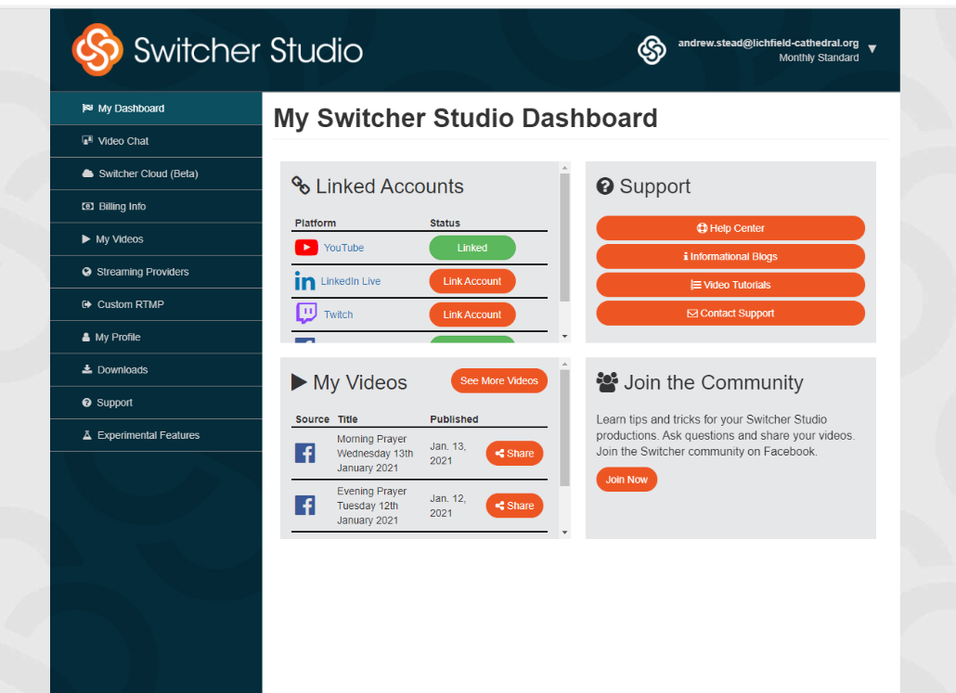

Equipment Needed.

You can use as little as one iPad – but it is recommended that at least one further device to act as a camera is utilised. It is also recommended, given that good audio is more important than good video, that an external mic is utilised and not to rely on the internal iPad microphone.

At the Cathedral we have as a core equipment base:

- WiFi Extender – As good as can be afforded and hard wired to the router if possible.
- iPad – to act as the Switcher Studio operating device. We now have the larger Ipad pro giving bigger screen size and ability to hardwire to the internet.]
- 5 other input devices – to act as cameras – I would recommend iPod touch as an inexpensive option but the higher end iPhones have better cameras. (We have a volunteer too with an Iphone 12 which has a truly amazing camera.)
- 5 boom mic stands with ‘phone or iPad mounts
- Focusrite Scarlett 2i2 3rd Gen USB Audio Interface
- 30m XLR cable to ½” Jack (feed from Cathedral PA)
- Headphones – ¼” jack.

Additionally for use with Organ and incorporating Sunday 1030 worship:

- Stereo Pair Mics - to pick up organ
- Pair mics for ambient sound
- 4x 30 XLR to XLR microphone cables
- 1x tall mic stand
- 2x boom mic stands
- 8 channel mixing desk.

We have through our experience learned that the iPad Pro gives us the capacity to plug in through the USB-C Connector both the audio and also a lan cable so that our internet connection is hard wired directly into the router. The WiFi extender is purely then working to provide connectivity to the camera/ipad devices.

We also have had issues with longer services with battery life and so we have a supply of external power packs which we use to extend the battery life of the cameras.

We have also gradually upgraded our audio input quality but what is outlined above does the job more than adequately.

We are happy to talk people through set up and offer advice from our experience.

Below you will find our set up and instructions from July. We have developed from this point as we became more experienced and understood the capability of the software and hardware, but these instructions give an insight into the basic operation and set up of the system.

1230 Eucharist and 1630 Evening Prayer Set up (Crossing)

- Source the text for setting up the live stream and copy – in WORD.
- Set up Control iPad for vision
  - Check that the device is connected to the Chapters Extended WiFi in the Settings Menu. All of the devices must be connected to this WiFi network.
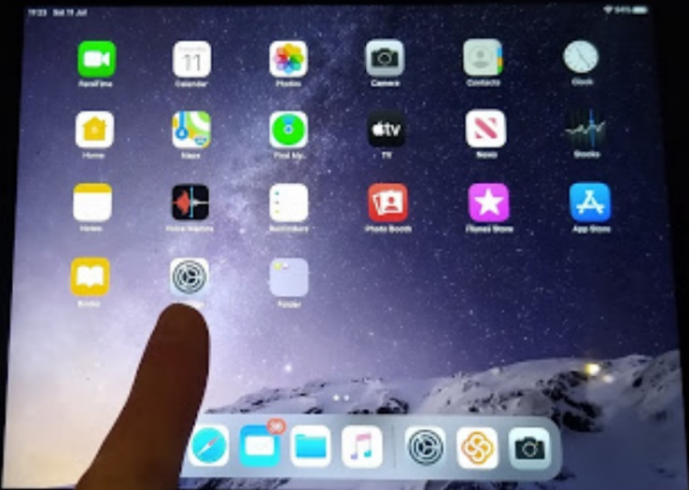

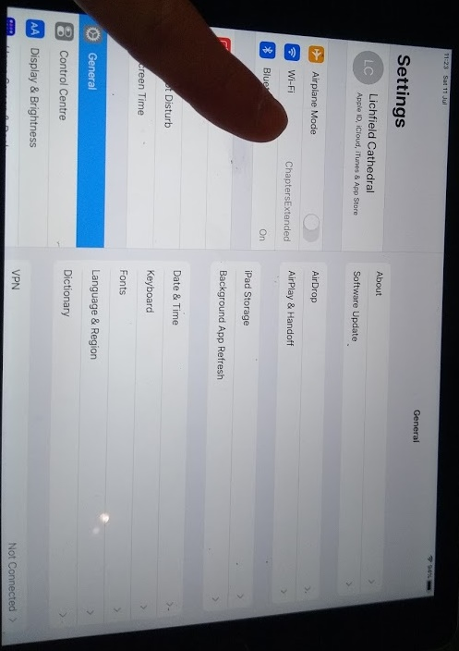

Tap here if it does not say ‘Chapters Extended’. Select from available WiFi networks

  - Open Switcher Studio on iPad, log in and begin by setting up the live stream.

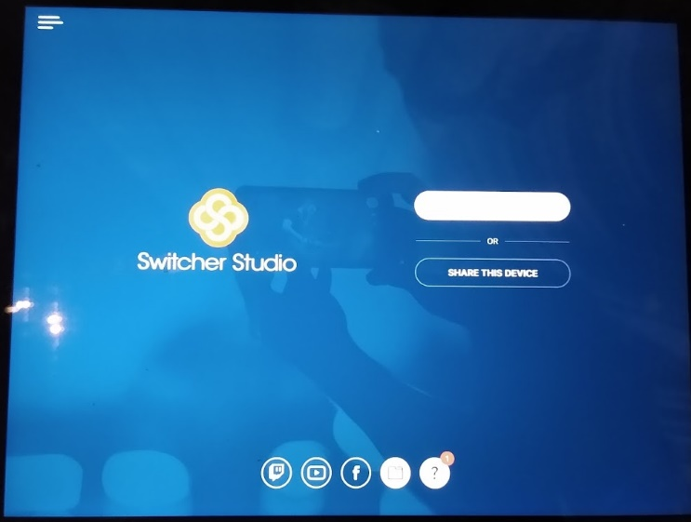
Press here.

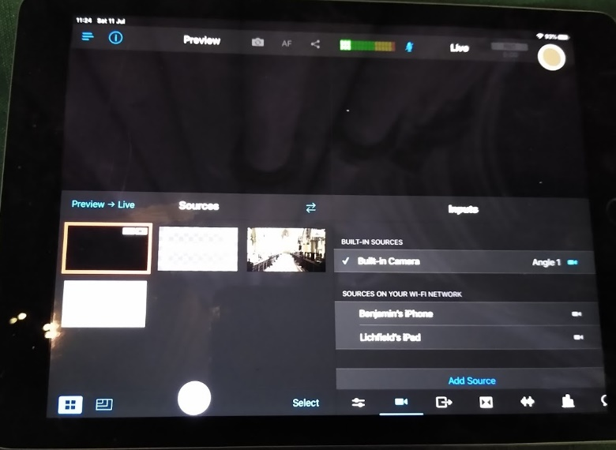

Press here…

4. When complete – press close.

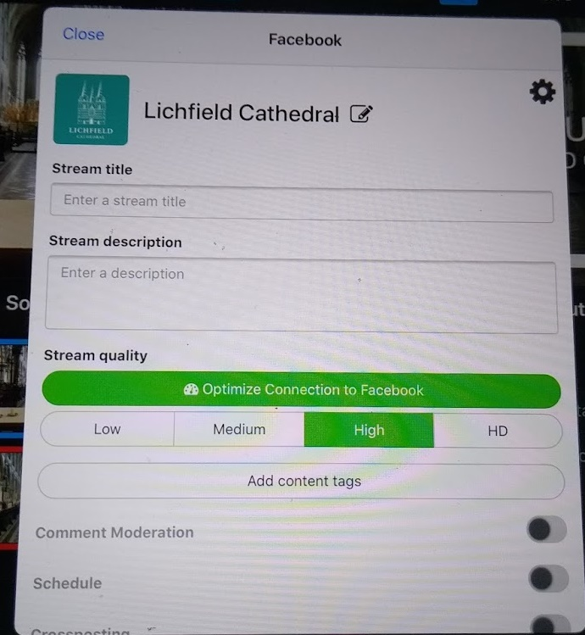
- Type in:
The Holy Eucharist: Day/Date/Year

2. Paste in (put finger in box and hold until the word paste appears)
Welcome to this celebration of the Holy Communion from Lichfield Cathedral celebrated by The Revd Canon Andrew Stead, Canon Precentor.
You can find resources to help join in by clicking here: https://www.lichfield-cathedral.org/what-s-on/daily-worship
Please consider making a donation to help us maintain our ministry during the pandemic and be ready to open our doors to the community again as soon as possible. Text SPIRES to 70331 to give £3, or visit www.lichfield-cathedral.org/donate. Thank you for your support.

3. Press this button – it will turn pink and run a protocol.
It will then turn green again. But tell you that Facebook settings are optimised.

  - Now set up camera devices x2 on their microphone stands.
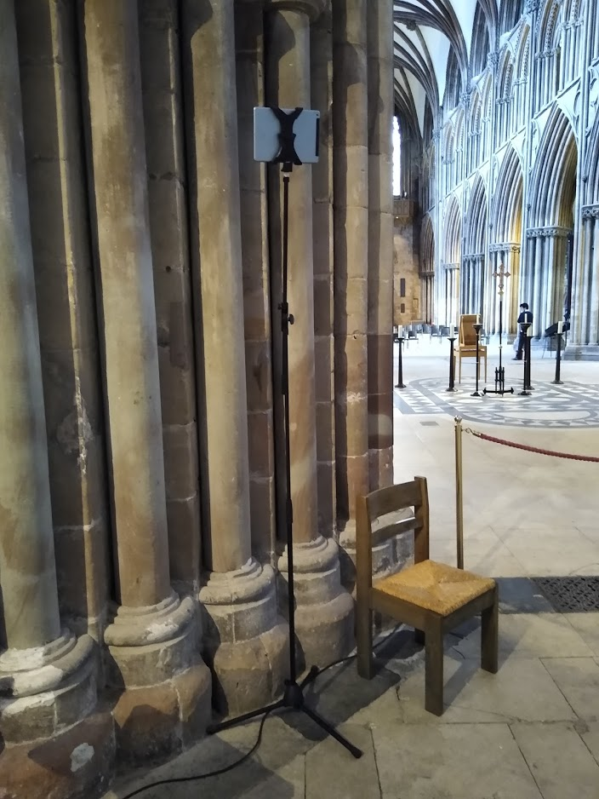
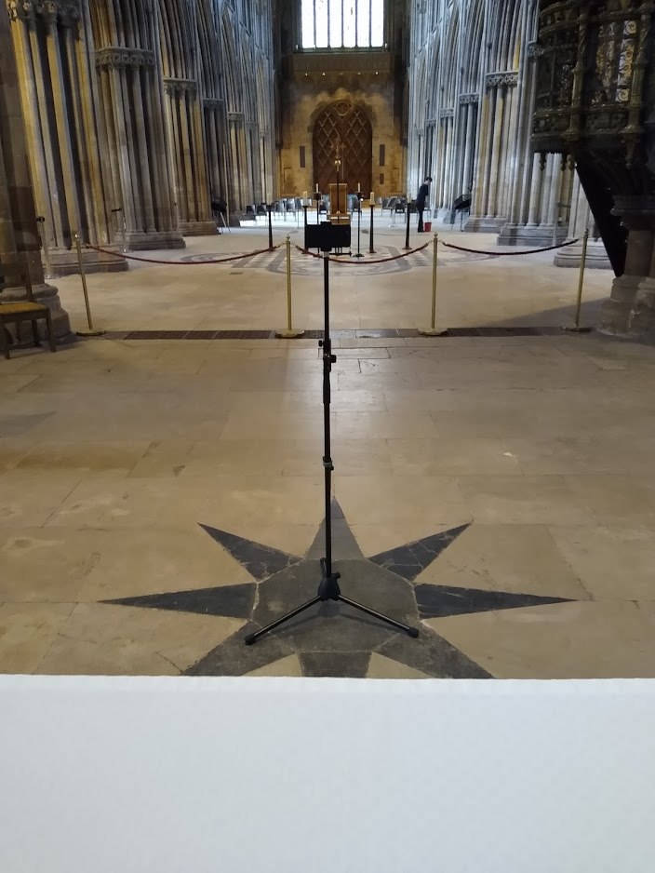

  - Turn them on and select - Share this device. Allow Camera.

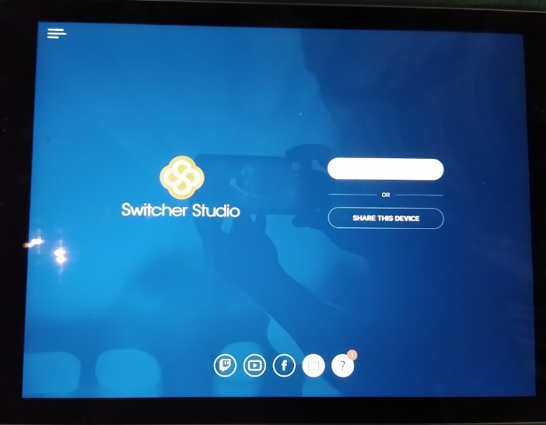
Note: you will not have to sign in on the software.

You may seen see this screen – press ‘ALLOW’

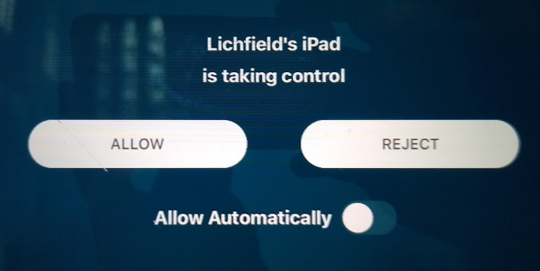

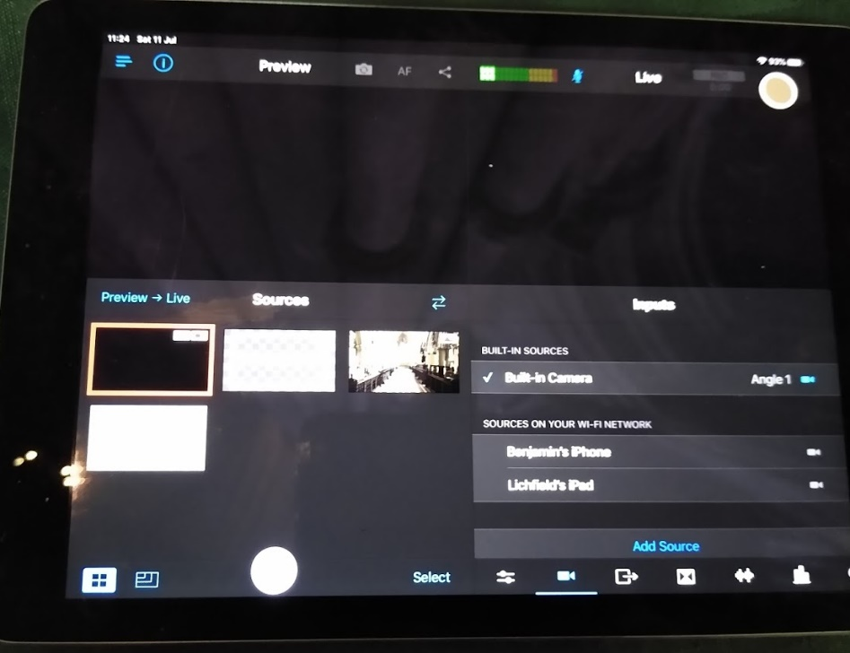
2. Tap on each device. The images from them should appear on the lower left sources screen and a blue tick next to the active devices. If not check the devices to see if permission is needed.
- On the Control device you will see this when the ‘Camera’ button is pressed. It will list the available devices.

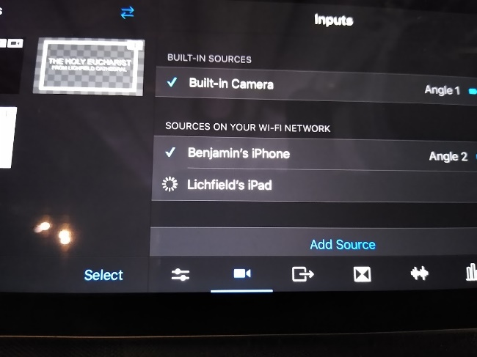

3. Uncheck the tick next to the built in camera – this will turn off the control iPad camera and prevent any accidental pictures of the table going out to the world.

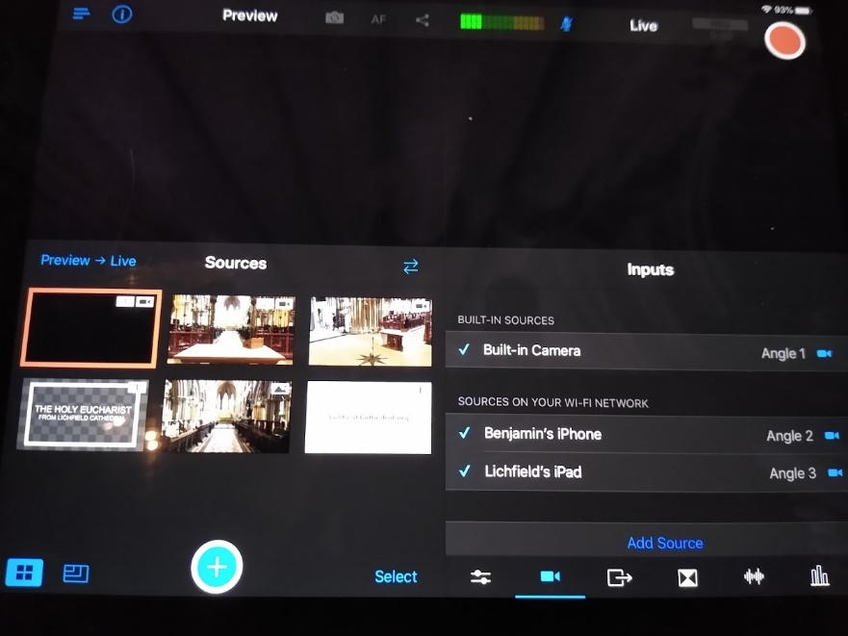

- Set up Audio input.
  - Plug in ½” Jack to 30m XLR cable into Headphone socket of Cathedral PA
  - Make sure that the volume control is set very low as shown below.

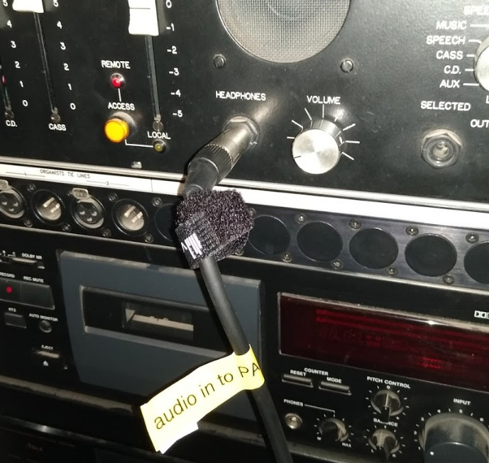

  - Plug XLR into iRig Pre and the iRig Pre into to the Control iPad
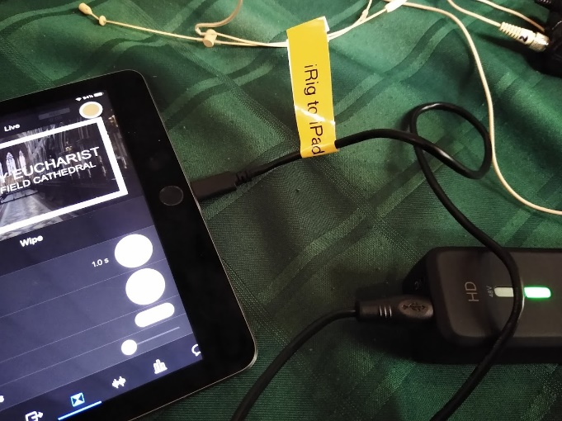
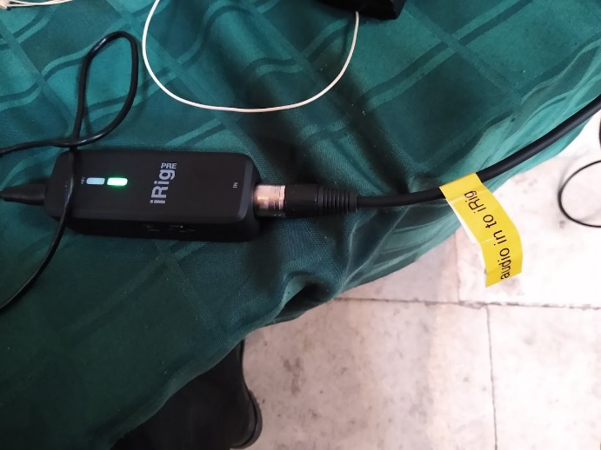

  - Check audio source is connected on Control iPad
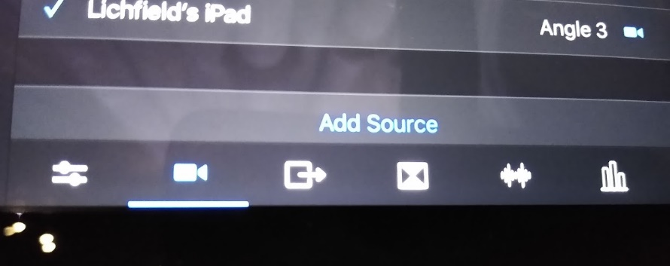
Tap here to access Audio feed settings.

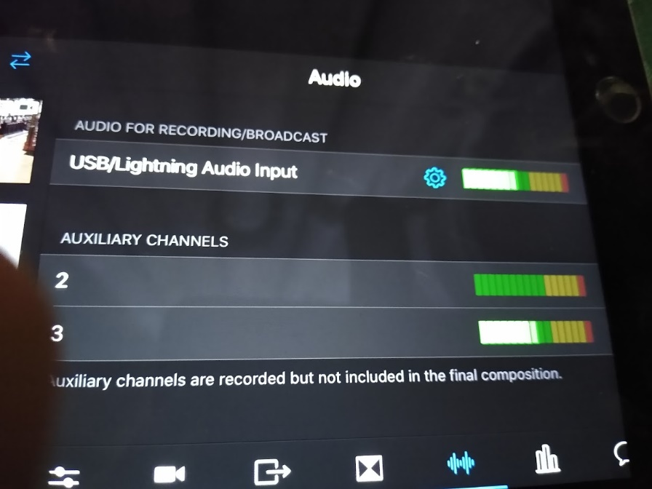
This is the important information. It should show the text: USB/Lightning Audio input.

  - Make sure that the Cathedral PA is on.
  - The Celebrant should have a radio mic – clip-on or ‘Kylie’ headset
  - Lollipop 3 – should be turned on an ‘Live’ stood by the crossing west pillar facing west (i.e. away from speakers) This will pick up ambient sound if the celebrant’s mic is turned off.
  - Audio Levels:
    - The output from the PA from the headphone socket should be set to the first mark i.e. LOW.
    - The gain on the iRig Pre should be set to ‘0’
    - The 48V power on iRig pre should be ‘off’
    - There is the facility to check the input from the PA through headphones plugged into the iRig pre – there is a volume control for the Headphones on the IRig pre. N.b. you are monitoring what is going into the device NOT what is going out into the Control iPad.
    - When speaking into the microphones the levels shown on the iPad audio monitor at the top of the screen should be in the top end of the green and into the orange sector, with loud sound registering in the red sector.
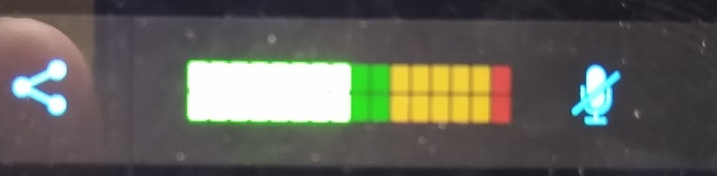

    - The light on the iRig also acts as a source meter and will go red if the sound peaks, if it reading red for a long time then check the headphone volume on the Cathedral PA is set as low as it will go without being off.

- Please note we have moved to a different interface now (details on page 1) - Focusrite Scarlett 2i2 3rd Gen USB Audio Interface.

- Begin to set up for the broadcast.
In the effects section set the Transition to ‘Cross Dissolve’ (it will default to ‘cut’ which is as unsubtle as it sounds in moving from camera to camera.)
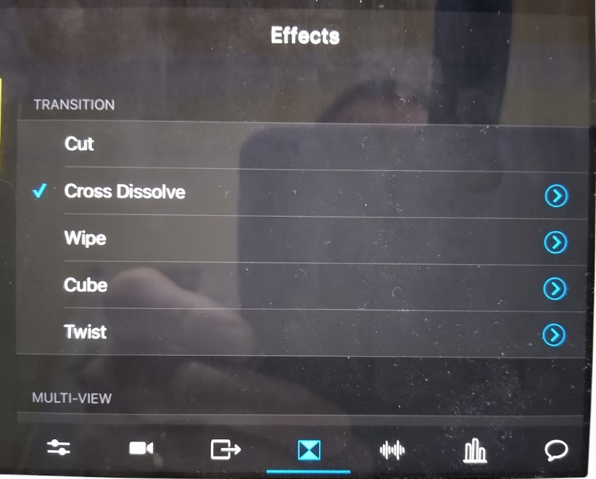
3. Tap here to access submenu
2. Tap here to select ‘Cross Dissolve’

- Tap here to access ‘Effects’ menu

In submenu – adjust the time of the effect from 1.0s to 1.5s (or there abouts)
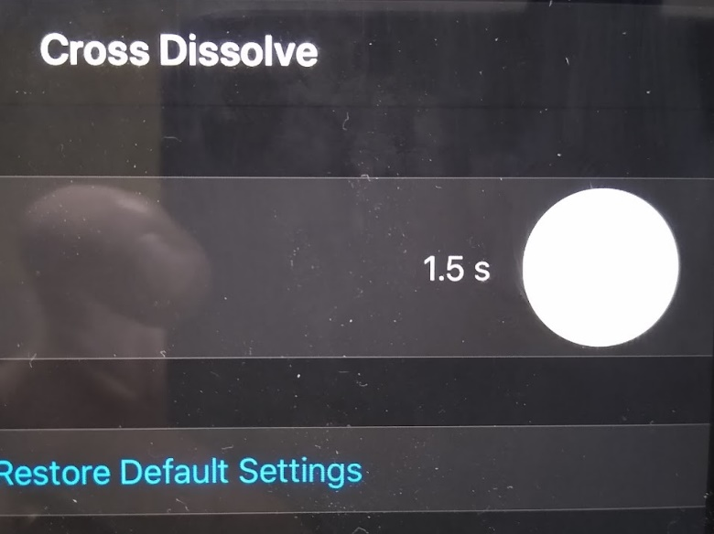

Use your finger to move the circle within the larger circle in a clockwise movement to take the setting from 1.0s to 1.5s. (or there abouts)

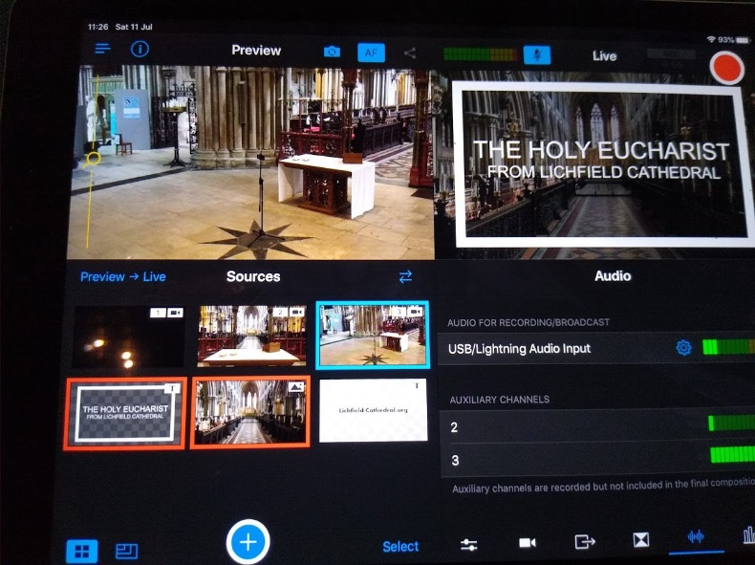
- The Control iPad is then set up and you are ready to go.

- Set up your first image –you here see a photo of the Quire with an overlay over the top in the ‘Live’ window to the top right. Next camera is ready in the left preview window. (Overlays stay over the top of the live image until deactivated by taping in the bottom right sources window.)

- Check that you are ready to go in the Broadcasting window (bottom right) to Facebook

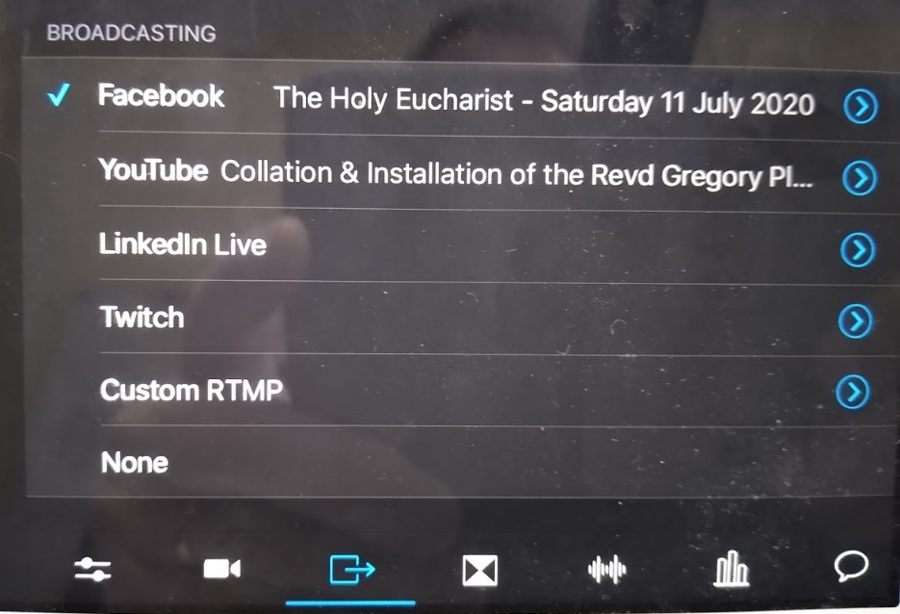
2. Check Facebook is selected. You will see part of the title of the stream in the box next to it.

- Broadcasting screen is activated by this button

- When you are ready to broadcast tap the RED button in the top right of the screen
- Tap to Broadcast
- ‘Live + Rec’ will turn red and the counter will begin to move.
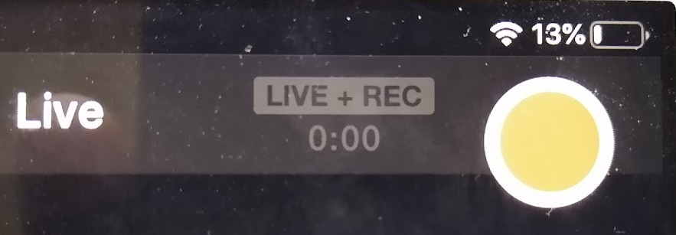

- Begin the broadcast one minute before the service start time. Remember though the audio is live.
- Turn off the over lay as you move to the camera on the celebrant as the service begins. The close up camera from in front of the altar will suffice for most of the service.
- You should go to the ‘longshot’ camera during the distribution of Communion when there is a congregation present and receiving communion.
- As the celebrant returns to the altar move back to the altar camera.
- As the celebrant finishes the service and has said goodbye. Move to the longshot camera and then ‘overlay’ the cathedral web address slide by taping it in the sources window. Count to 10 and then tap the end button (top right)

- Ending the Broadcast
Tap here to end the live stream broadcast
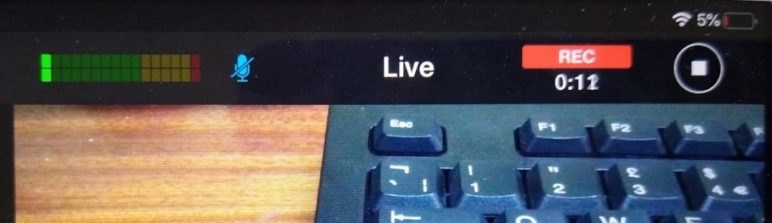

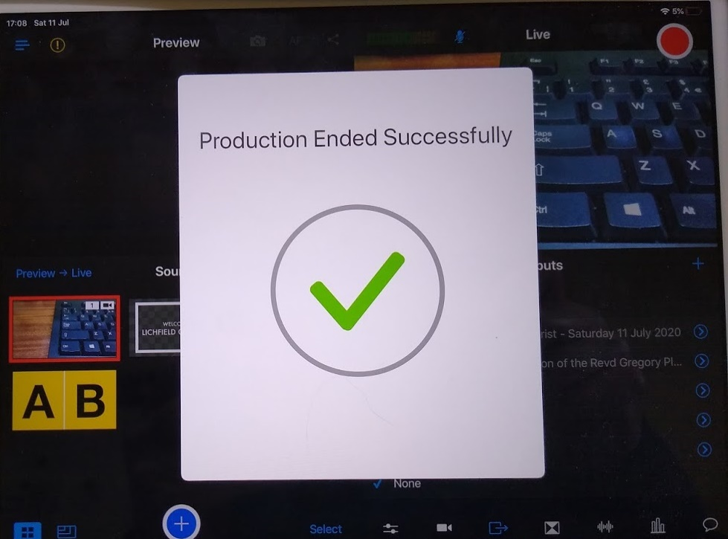
You will see this when you are off line.

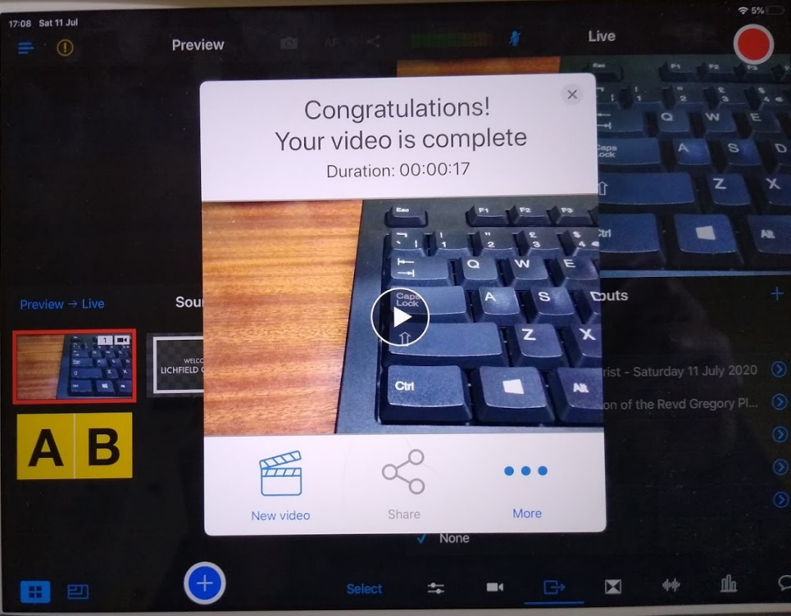
You’ve done!

You can check what has gone out by pressing here.

- Pack away and it is very important that all the devices are charged up for the next service.

Conclusion

With hands on training this guide should serve to support the operator. There is the option of just recording to the device rather than live streaming a broadcast to Facebook or YouTube and anyone using the equipment for the first time on their own might take the opportunity of having a dummy run to review and view for themselves the picture and audio quality.

Follow this link to the Facebook showing the Eucharist from Saturday 11 July 2020 to see what is possible with only a little practice.

https://www.facebook.com/LichfieldCathedral/videos/732545160855455/

Setting up for Sundays at 1030

The use of the organ will and possibly a cantor will require a little more audio preparation. Similarly, the use of subtitling to enable participation in the liturgy will need the use of a laptop and the learning of split screen in Switcher Studio.

I will, when I set it up, draw up a further illustrated guide for that service. It will have to incorporate the use of a mixer desk for audio as well as the laptop.

I will look to finding a volunteer, of suitable technical ability, to run Sunday’s broadcasting. The vergers cannot be doing that, the PA and monitoring the congregation.

The Revd. Canon Andrew Stead | Canon Precentor
Version 3 - January 2021

