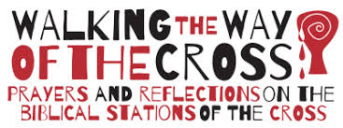
All Saints’ Parish Church, Streetly

Fifteen different scripture-based daily devotions from
Passion Sunday
to
Easter Day
Focusing on the Bible stories
of Jesus’ passion, death
and resurrection.
Welcome

The body of Christ in Streetly is currently a dispersed church. We not able to meet in our church buildings. This Passiontide, Holy Week and Easter you are offered the opportunity to take and read these Stations of the Cross.

Stations of the Cross have been part of Christian devotions for many centuries, they offer a vivid way of following in the steps of Jesus on the way to the cross. In the earliest of days, Christians would walk the path from Pilate’s house to Calvary, pausing for prayer and reflections at various significant points.

These devotions offer a way of walking the via dolorosa (way of sorrows) as we recall key moments from the passion and death of Jesus.

There are fifteen different scripture-based daily devotions from Passion Sunday to Easter Day, focusing the Bible stories of Jesus’ passion, death and resurrection. The images are drawn by Nicholas Markell and the devotions written by Stephen Cottrell Bishop of Chelmsford, Archbishop of York, designate.

The devotions enable us to hear gain the story of God’s amazing love for all people and to discover again, his plan to bring us back to himself. In these difficult and uncertain times, the story of Jesus death and resurrection offers us hope and joy.

You can read and pray by yourself, joining your prayers with countless Christians who will be doing the same. The suggestion is to begin on Passion Sunday and follow a reading a day till Easter Sunday.

May God Bless you as we journey together as god’s people dispersed, this Passiontide, Holy Week and Easter.

Reverend Mandy Walker
March 2020
The Gathering

In the name of the father,
And of the Son,
And of the Holy Spirit.
Amen.

Jesus told his disciples, “If you want to become my followers, let them deny themselves and take up their cross and follow me.
For those who want to save their life will lose it, and those who lose their life for my sake will find it’
Matthew 16.24,25

Once you were far off, but now in union with Christ Jesus we have been brought near through the shedding of Christ’s blood, and he is our peace.
Ephesians 2.13,14

Almighty and everlasting God,
Who in your tender love towards the human race
sent your Son our Saviour Jesus Christ
to take upon him our flesh
and to suffer death upon the cross:
grant that we may follow the example
of his patience and humility,
and also, be made partakers of his resurrection:
through Jesus Christ your Son our Lord,
who is alive and reigns with you,
in the unity of the Holy Spirit,
one God, now and forever.
Amen.

Holy God,
Holy and strong,
Holy and immortal,
Have mercy upon us.

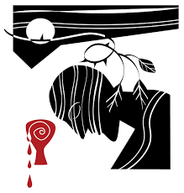

First Station:

Jesus in agony in
the Garden of Gethsemane

First Station:
Jesus in agony in the Garden of Gethsemane

We adore you, O Christ, and we bless you,
Because by your holy cross
You have redeemed the world.

Reading

They went to a place called Gethsemane; and he said to his disciples, ‘Sit here while I pray.’ He took with him Peter and James and John and began to be distressed and agitated. And he said to them, ‘I am deeply grieved, even to death; remain here, and keep awake.’ And going a little farther, he threw himself on the ground and prayed that, if it were possible, the hour might pass from him. He said, ‘Abba, Father, for you all things are possible; remove this cup from me; yet, not what I want, but what you want.’ Mark 14.32-36

Reflection

He began to be distressed and agitated

I liked him when he was strong: turning over tables, casting out demons, catching the scribes in the snare of rhetoric. He was strong eve when kneeling down and washing feet. When he was strong, I was strong, and it was a joy to follow him.
Oh, I don’t get me wrong, following him wasn’t east. I didn’t understand him. But he made me feel good about myself and good about the world. He brought hope. A stability and a purpose that was lacking in everybody else. And I liked that the religious and the powerful felt the same way too – only what was a joy to me was a terrible threat for them.
continued……
But I believed in him. I believed that he could even overcome their power.
So, I followed. Only at a distance. I’m not Peter or John, nor even Mary. But I see something in him that I want so badly in me. I want my demons cast out. I want my feet washed. I want his stories to be true, those wonderful stories of hoe and forgiveness and of a God who loves me.
So, it isn’t easy to see him weak, to see him scared. The others are all asleep. But he is awake with restless agitation. He sees what is coming, but he wishes it were different. I know this feeling too, knowing where you must go, yet longing for another way.

Prayer

Lord Jesus, you entered the garden of fear and faced the agony of your impending death: be with those who share that agony and face death this day. You shared our fear and knew the weakness of our humanity: give strength and hope to the dispirited and despairing. To you, Jesus, who seated blood, be honour and glory with the Father and the Holy Spirit, now and forever. Amen.

Holy God,
Holy and strong,
Holy and immortal,
Have mercy upon us.

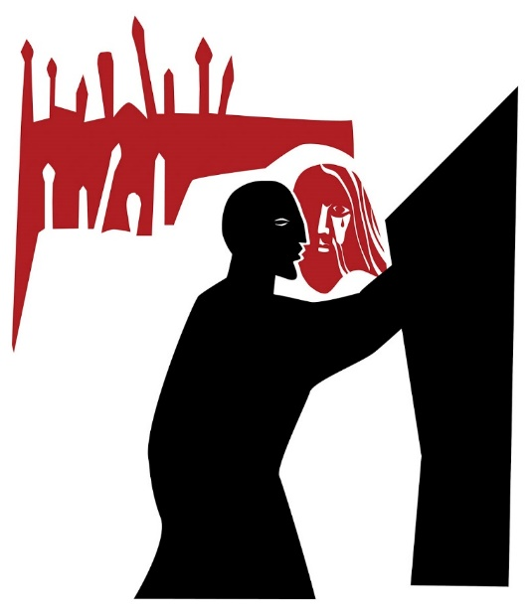

Second Station:

Jesus betrayed by Judas
and arrested

Second Station:
Jesus betrayed by Judas and arrested

We adore you, O Christ, and we bless you,
Because by your holy cross
You have redeemed the world.

Reading

Immediately, while he was still speaking, Judas, one of the twelve, arrived; and with him there was a crowd with swords and clubs, from the chief priests, the scribes, and the elders. Now the betrayer had given them a sign, saying, ‘The one I will kiss is the man; arrest him and lead him away under guard.’ So, when he came, he went up to him at once and said, ‘Rabbi!’ and kissed him. Then they laid hands on him and arrested him.

Mark 14.43-46

Reflection

Then they laid hands on him

Here’s the thing. If Judas hadn’t betrayed him, someone else would have. Everyone was anxious. Everyone knew things had to come to a head. So, it was like he wanted someone to hand him over, and then this wad the chance he needed to show people who he really was. So, we didn’t get in the way.
He told us he was from god. We even started to believe it, that he might be the Messiah we had been waiting for. After all, don’t we all long for God to come to us. So, this was his chance: a chance to demonstrate his power, a chance to weave the magic of his words, the ones that had entranced us.
continued….
But it wasn’t working out that way. So, it is convenient to dump the blame on Judas, even when the truth is far more complicated, for more uncomfortable. Because I have betrayed him. I have betrayed him in a thousand little ways by all my acts of egocentric self-promotion: by my failure to love, and by my refusal to wah feet; because I want things my way, not his.
He taught me that I will gain life by losing it. But I can’t accept that. I still cling on to what Ove got. And I’m ready to dump him if necessary.

Prayer
Lord Jesus, you were betrayed by the kiss of a friend be with those who are betrayed and slandered and falsely accused. you knew the experience of having your love thrown back in your face for mere silver: be with families which are torn apart by mistrust or temptation. To you, Jesus, who offered your face to your betrayer, be honour and glory with the father and the Holy Spirit , now and forever. Amen.

Holy God,
Holy and strong,
Holy and immortal,
Have mercy upon us.

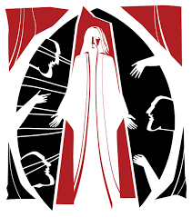

Third Station:

Jesus condemned by the Sanhedrin

Third Station:
Jesus condemned by the Sanhedrin

We adore you, O Christ, and we bless you,
Because by your holy cross
You have redeemed the world.

Reading

Now the chief priests and the whole council were looking for testimony against Jesus to put him to death; but they found none. For many gave false testimony against him, and their testimony did not agree. Some stood up and gave false testimony against him, saying, ‘We heard him say, “I will destroy this temple that is made with hands, and in three days I will build another, not made with hands.”’ But even on this point their testimony did not agree. Then the high priest stood up before them and asked Jesus, ‘Have you no answer? What is it that they testify against you?’ But he was silent and did not answer. Again, the high priest asked him, ‘Are you the Messiah, the Son of the Blessed One?’ Jesus said, ‘I am and “you will see the Son of Man
seated at the right hand of the Power”, and “coming with the clouds of heaven.”’ Then the high priest tore his clothes and said, ‘Why do we still need witnesses? You have heard his blasphemy! What is your decision?’ All of them condemned him as deserving death.
Mark 14.55-64

Reflection
He was silent
He wouldn’t really answer their questions. That frustrated us as much as them. We wanted him simple. We wanted him plain. But he comes to us all in the frail, undignified vulnerability of flesh.
“I am.” That’s what he kept saying. “I am the bread. I am the vine. I am the ruth. I am the way”
That was all he had to say when they arrested him. “I am he.” And it was all they needed him to say to kill him. For these are the words that god said to Moses when he refused to answer his question straight. “I am who I am. I will be what I will be. “
So, they didn’t look for anything else. They missed the overwhelming silence of his presence before them which was, if they could have seen it, the breath that is taken between one movement of the dance ending and another about to start.
I didn’t see it either. I too was disillusioned: I too was unimpressed for the music he would sing. Though I am learning that he is like bread. Broken. And he is like wine. Poured. And he is a truth I never dreamed of. He is a way I find it hard to follow. How is it that the way to life leads straight to dying?

Prayer

Lord Jesus, you were the victim of religious bigotry be with those who are persecuted by small-minded authority. You faced the condemnation of fearful hearts: deepen the understanding of those who shut themselves off from the experience and wisdom of others. To you, Jesus, unjustly judged victim, be honour and glory with the Father and the Holy Spirit, now and forever. Amen.

Holy God,
Holy and strong,
Holy and immortal,
Have mercy upon us.

Fourth Station:

Peter denies Jesus

Fourth Station: Peter denies Jesus

We adore you, O Christ, and we bless you,
Because by your holy cross
You have redeemed the world.

Reading

At that moment the cock crowed for the second time. Then Peter remembered that Jesus had said to him, ‘Before the cock crows twice, you will deny me three times.’ And he broke down and wept.
Mark 14.72

Reflection
I do not know this man
Peter got it right for once. He said he didn’t know him. He said he wasn’t with him. That was how we were all feeling. We didn’t know him. We weren’t with him anymore.
We thought he would vindicate himself. Wasn’t that where everything else had bene leading? How could we think otherwise when he rode into Jerusalem on a donkey just like the prophets said? Or when he declared that the temple could be torn down and rebuilt in three days?
But now we just felt stupid. And scared. He wasn’t the Messiah. We didn’t really know him at all. Maybe we never had?
And that’s how I feel at the moment. I feel stupid. I feel scared. I feel like I don’t know him and can’t follow him. But I can’t let go of him either. I keep thinking that something else will happen that will make sense of all this senselessness.
continued……
When the cook crows it isn’t just Peter who is reminded of his failing. I know with the dawn if each new day that I am not the person I am meant to be, that I have much to learn about love, that his words of peace and forgiveness have not yet entered my soul and changed me so that even if I was led away like him I could keep on loving.

Prayer

Lord Jesus, as Peter betrayed you, you experienced the double agony of love rejected and friendship denied: be with those who know no friends and are rejected by society. You understand the anxieties of those who fear their future. To you, Jesus, who gazed with sadness at your lost friend, be honour and glory with the father and the Holy Spirit, now and forever. Amen.

Holy God,
Holy and strong,
Holy and immortal,
Have mercy upon us.

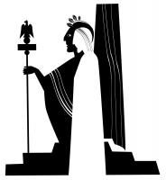

Fifth Station:

Jesus judged by Pilate

Fifth Station: Jesus Judged by Pilate

We adore you, O Christ, and we bless you,
Because by your holy cross
You have redeemed the world.

Reading

Pilate asked them, ‘Why, what evil has he done?’ But they shouted all the more, ‘Crucify him!’ So, Pilate, wishing to satisfy the crowd, released Barabbas for them; and after flogging Jesus, he handed him over to be crucified.
Mark 15.14. 15

Reflection

Wishing to satisfy the crowd

Pilate wasn’t interested in bread. Nor in those enigmatic declarations that has so enraged the scribes. He was after the truth. And like all weak men, especially those with too much power, he wanted a truth that would set him free- free from responsibility, that is. So, when he realsied that he couldn’t bargain with Jesus, eh made friends with the crowd. And they, all too predictable, bayed for blood in return. That was, after all, the usual price.
Did I say “they?” Did I pretend I wasn’t in the crowd? Did I try to give then impression I was standing at the edge. A mere observer? Don’t believe it/ I too love to run with the crowd and feel the exhilaration of a moral certainty that can crush another, I too love to count some in and rule some others out.
continued…..
Of all people I am to be most pitied. I cannot even muster up the courage to confess my sins, too proud to be forgiven. Why, I’d rather burn in hell than face the embarrassment of my actions. I am just like Pilate. I don’t want to be forgiven. And even as I say this, as my shrinking heart becomes less willing to be touched by love, I cry out. Where can I find transfusion for my heart? Where can I find irrigation for my dried-up soul? Where is the blood and water I crave?

Prayer

Lord Jesus, you were condemned to death for political expediency be with those who are imprisoned for the convenience of the powerful. You were the victim of unbridled injustice: change the minds and motivations of oppressors and exporters your way of peace. To you, Jesus, though condemned, be honour and glory with the Father and the Holy Spirt now and forever. Amen.

Holy God,
Holy and strong,
Holy and immortal,
Have mercy upon us.

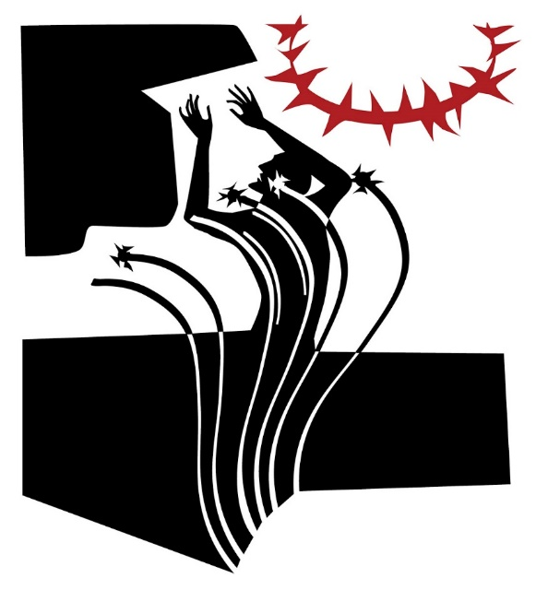

Sixth Station:

Jesus scourged and crowned
with thorns

Sixth Station:
Jesus Scourged and crowned with thorns

We adore you, O Christ, and we bless you,
Because by your holy cross
You have redeemed the world.

Reading

And they clothed him in a purple cloak; and after twisting some thorns into a crown, they put it on him. And they began saluting him, ‘Hail, King of the Jews!’ They struck his head with a reed, spat upon him, and knelt down in homage to him.
Mark 15.17-19

Reflection

Twisting some thorns into a crown

What begins in tragedy, ends in farce. He said he was a king, so dress him up as one: twist some thorns into a crown: and so that everyone can enjoy the joke, write it in three languages upon the cross: Jesus of Nazareth, King of the Jews. Then beat him within an inch of his life, the stupid dreamer. A king indeed, what a joke.
Silence. The silence of horror. The silence of shame. I watch from a distance and can only think how glad I am it is not me, and how relieved I am that no one knows I follow him.
My life does not display the marks of love. There are no distinguishing features that could cause offence or make others wonder whether love was real: real, that is, beyond the love that holds us to ourselves and pulls down the shutters on the world.
continued…..
My drawbridge is up. My moat I full. My defenses are at the ready. You won’t catch me being so stupid as to love.
Then they strip him. My king. The one who stands alone. The one who breaks down the walls. The one whose agenda for my life requires that I stand naked too. I cannot bear to follow him. And I cannot bear to stop, either.

Prayer

Lord Jesus, you faced the torment of barbaric punishment and mocking tongue: be with those who cry out in physical agony and emotional distress. You endured unbearable abuse: be with those who face torture and mockery in our world today. To you, Jesus, the King crowned with thorns, be honour and glory with the Afth4er and the Son and the Holy Spirit, now and forever.
Amen.

Holy God,
Holy and strong,
Holy and immortal,
Have mercy upon us.

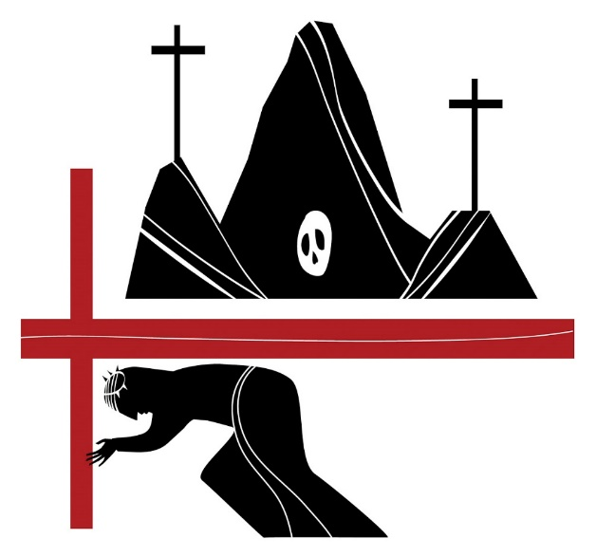

Seventh Station:

Jesus carries the cross

Seventh Station: Jesus carries the cross

We adore you, O Christ, and we bless you,
Because by your holy cross
You have redeemed the world.

Reading

After mocking him, they stripped him of the purple cloak and put his own clothes on him. Then they led him out to crucify him.
Mark 15.20

Reflection

To crucify him

There is no easy way of carrying a cross. There is no handle. Its weight is harp and crushing. Its meaning obvious. Those clever men who devised such a clever ways of killing perfected with these beams of wood a tortuous cycle of almost unremitting suffering, the crucified man switching weight from nailed ankles to nailed wrists: buying time, relieving pressure, eking out he hours, so that sometimes crucifixions would go on for days.
It meant the crowds got their monies worth, and that there was no small consideration. Obedience was demanded and it was exacted through fear, and your own self-righteousness could be coddled with the morbid spectacle of someone else’s dying. It was, therefore, an additional indignity to be made to carry the cross, like having to fumble with rope to tie the knot of you own nose.
continued…..

Bu the carried it well. Trampling through the crowded lanes around Jerusalem. Seeing the crazy, chaos of the crowd. Hearing the abuse and their grief. Everyone loves a good killing. As long as its not your own.
And he carried so many other things as well. Our sins. Our sorrows. And a million disappointments about all the ways that we got him wrong. And these were heavier still.

Prayer

Lord Jesus, you carried the cross through the rough streets of Jerusalem. Be with those who are loaded with burdens beyond their strength. You bore the weight of our sins when you carried the cross: help us to realize the extent and the cost of the cross: help us to realize the extent and the cost of your love for us. To you, Jesus bearing a cross not your own, be honour and glory with the Father and the Son and the Holy Spirit, now and forever.
Amen.

Holy God,
Holy and strong,
Holy and immortal,
Have mercy upon us.

Eighth Station:

Simon of Cyrene helps Jesus to carry the cross

Eighth Station:
Simon of Cyrene helps Jesus carry the cross

We adore you, O Christ, and we bless you,
Because by your holy cross
You have redeemed the world.

Reading

They compelled a passer-by, who was coming in from the country, to carry his cross; it was Simon of Cyrene, the father of Alexander and Rufus.
Mark 15.21

Reflection
They compelled a passer-by
When he stumbles for a third time – the cross beam he was carrying thumping heavily to the ground – even those who mocked him held their breath. Was the spectacle going to end before it had properly started? Were they to be cheated of a nice long death?
The soldiers were impatient. They had work to do and homes to go to. Someone was going to have to help. Their eyes scanned the crowd. Whom should they pick? And we all averted our gaze, begging the God we did not believe in to pick someone else.
And the one who was chosen? Do not think of hm as a volunteer. His eyes were down just like mine. He was just in the wrong place at the wrong time, just not quick enough to hide, and they dragged him roughly to the front and gave him the cross to carry. And its splinters pierced his flesh too.
continued…..
It was Simon, in town from Cyrene. You know, Alexander and Rufus’ dad. Who would have believed that? For somehow carrying that cross, albeit reluctantly, changed him. He says, if you can get a word in edgeways, that he has never put it down.
And so, I wonder, why didn’t they pick me? I, who am neither volunteer nor recruit, still stand on the edge, wondering what holding the cross feels like.

Prayer

Lord Jesus, you were worn down by fatigue be with those from whom life drains all energy. You needed the help of a passing stranger: give us the humility to receive aid from others. To you Jesus, weighed down and with exhaustion and in need of help, be honour and glory with the Father and the Son and the Holy Spirit, now and forever. Amen.

Holy God,
Holy and strong,
Holy and immortal,
Have mercy upon us.

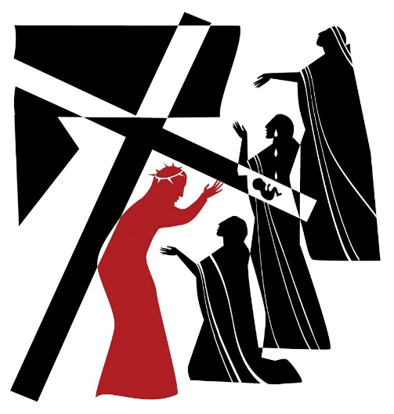

Ninth Station:

Jesus meets the women
of Jerusalem

Ninth Station: helps meets the women of Jerusalem

We adore you, O Christ, and we bless you,
Because by your holy cross
You have redeemed the world.

Reading

A great number of the people followed him, and among them were women who were beating their breasts and wailing for him. But Jesus turned to them and said, ‘Daughters of Jerusalem, do not weep for me, but weep for yourselves and for your children. For the days are surely coming when they will say, “Blessed are the barren, and the wombs that never bore, and the breasts that never nursed.” Then they will begin to say to the mountains, “Fall on us”; and to the hills, “Cover us.” For if they do this when the wood is green, what will happen when it is dry?’
Luke 23.27-31

Reflection
Weep for yourselves
He always had an affinity with tears. He notices them. Even the hidden ones, that drop inside the soul and keep falling even when your face is smiling, and no one notices the grief behind the confident façade.
He always asked why: why are you weeping: what is the story of your tears? He knew that we would never find an answer to our sorrow that as second hand, or off the shelf. It could never be someone else’s answer, no matter how compelling.
continued……

Until we find the answer in ourselves, until we understand our own grief, until we are able to strip back the layers of pretense and see afresh the cause of our disquiet and our pain, we would always be alone in our sorrow. It would always be an emptying out our grief and never a filling in of grace.
But if we saw, just for a moment , the heart of our dismay, our terrible separation from love, then we would also see the means of grace, see – and now I give you second, for I have not yet seen it for myself, only glimpsed its terrifying beauty -the face of God in this about to eb crucified man.
So, when the women who followed in the crowd wept and tore their clothing, he asked them not to weep for him -but for themselves.

Prayer

Lord Jesus, the women of Jerusalem wept for you: move us to tears at the plight of the broken on our world. You embraced the pain of Jerusalem, the city of peace. Bless Jerusalem this day and lead it to the path of profound peace. To you, the King of Peace who wept for the city of peace, be honour and glory with the Father and the Son and the Holy Spirit, now and forever.

Amen.
Holy God,
Holy and strong,
Holy and immortal,
Have mercy upon us.

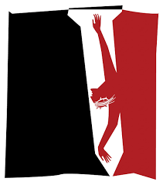

Tenth Station:

Jesus is crucified

Tenth Station: Jesus is crucified

We adore you, O Christ, and we bless you,
Because by your holy cross
You have redeemed the world.

Reading

And they crucified him, and divided his clothes among them, casting lots to decide what each should take.
Mark 15.24

Reflection

To decide what each should take

When we die, we relinquish control of all our possessions. All the things that seemed to be so important are laid down. They pass to others or are simply bagged up and disposed of. I may be very firmly attached to this piece of jewelry, a wedding ring perhaps, or to this item of clothing: this may be that cherished something I would rescue from a burning house, but in death I am detached from it. Even my most precious and familiar possession, the very flesh I occupy, no more than that, the flesh and blood I know to be me, is taken: the spirit that imbibes my flesh, dragged out of it.

When they had nailed him to the cross, his arms and legs secure, and the terrible cycle had begun, the soldiers simply sat, as if at rest, though I suppose on guard, and laughing, drew lots for his clothes. With this, his death, really began. And I could see that it was my death as well. Oh yes, in all probability I had some years to idle away before the actual moment came.

continued……
But as they rolled the dice for his clothes, I looked at mine, and at my flesh and at the bones beneath it and saw it all slipping away into oblivion.

Only the laughter of those who mocked me remained. And his crying out.

Prayer

Lord Jesus, you bled in pain as the nails were driven into your flesh: transform through the mystery of your love the pain of those who suffer> To you, Jesus, our crucified Lord, be honour and glory with the Father and the Son and the Holy Spirit, now and forever. Amen.

Holy God,
Holy and strong,
Holy and immortal,
Have mercy upon us.

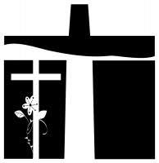

Eleventh Station:

Jesus promises the kingdom to the penitent thief

Eleventh Station:
Jesus promises the kingdom to the penitent thief

We adore you, O Christ, and we bless you,
Because by your holy cross
You have redeemed the world.

Reading

One of the criminals who were hanged there kept deriding him and saying, ‘Are you not the Messiah? Save yourself and us!’ But the other rebuked him, saying, ‘Do you not fear God, since you are under the same sentence of condemnation? And we indeed have been condemned justly, for we are getting what we deserve for our deeds, but this man has done nothing wrong.’ Then he said, ‘Jesus, remember me when you come into your kingdom.’ He replied, ‘Truly I tell you, today you will be with me in Paradise.’
Luke 23.39-43

Reflection
Jesus, remember me
I saw myself crucified on either side of him. Each criminal had my face. On one side, I mocked him with everyone else. I saw his stupidity, the glorious audacity of his claims and their demise. He couldn’t even save himself.
And on the other side, I cried out to him. I cried out from the depths of my distress. Not out of penitence: it was something larger, much deeper than that. I saw the heart of my own sorrow and its terrible loneliness.
continued….
I saw myself cur adrift, my life falling and falling into the endless abyss of the darkness that swallows those who put themselves outside God. I wasn’t being punished. It would have been so much easier if I was. Then I could have protested my innocence. Or asked for leniency. But I knew I had done wrong and that love, and forgiveness were available if I had the grace to receive them. So, I didn’t turn to him – not straight away – nut to the side of me that mocks him: after all, we were only getting what we deserved, but this man had done no wrong.
And still he has not spoken. He is waiting for me. Knowing that I must find this thing within myself. Not just penitence, but love. Not merely acquittal, but hope. “Remember me”, I say to him, “in that kingdom of yours”.

Prayer

Lord Jesus, even in your deepest agony you listened to the crucified thief: hear us as we unburden to you our deepest fears. You spoke words of love in your hour of death: help us to speak words of life to a dying world. To you, Jesus who offer hope to the hopeless, be honour and glory with the father and the Holy Spirit, now and forever. Amen.

Holy God,
Holy and strong,
Holy and immortal,
Have mercy upon us.

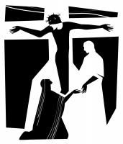

Twelfth Station:

Jesus on the cross:
his mother and his friend

Twelfth Station:
Jesus on the cross: his mother and his friend

We adore you, O Christ, and we bless you,
Because by your holy cross
You have redeemed the world.

Reading

When Jesus saw his mother and the disciple whom he loved standing beside her, he said to his mother, ‘Woman, here is your son.’ Then he said to the disciple, ‘Here is your mother.’ And from that hour the disciple took her into his own home.
John 19.26-27

Reflection
Jesus saw his mother
His mother stood there all afternoon. And he commanded her to those who loved him. She stood as near to death as she was permitted. She did not avert her gaze. She did not flinch. The tears that would erupt were held against the levy of her determined vigil. It was as if a sword had pierced her heart too when they pierced his.
They saw each other. Like sons do with mothers. And mothers do with sons. They couldn’t embrace, but they were held together in the vice -like grip of love; and those who saw each it knew it could not be undone. In his dying, and his reaching out to those from whom he had learnt human love, we see what love looks like. Love is not a remedy, not a good-luck charm. Love is not falling in love.
continued….
Love is the costly and determined insistence to stick with what is right and to patiently go on standing by those you love.
It was what was most infuriating that afternoon for those who wanted to rid themselves of him, even for my own embarrassed relief that following him might be over at last; he went on loving. He loved those who nailed him to the cross. He loved those who hung beside him. He loved those who mocked and derided him. He knew that the only way to conquer such evil was to love it to submission.

Prayer

Lord Jesus, your mother and your dearest friend stayed with you to the bitter end, even while racked with pain and you ministered to them be with all broken families today and care for those who long for companionship. Yu cared for your loved ones even in your death- those: give us a love for one another that is stronger even than the fear of death. To you, Jesus, loving in the face of death, be honour and glory with the father and the Holy Spirit, now and forever. Amen.

Holy God,
Holy and strong,
Holy and immortal,
Have mercy upon us.

Thirteenth Station:

Jesus dies on the cross:

Thirteenth Station: Jesus dies on the cross

We adore you, O Christ, and we bless you,
Because by your holy cross
You have redeemed the world.

Reading

At three o’clock Jesus cried out with a loud voice, ‘Eloi, Eloi, lema sabachthani?’ which means, ‘My God, my God, why have you forsaken me?’ When some of the bystanders heard it, they said, ‘Listen, he is calling for Elijah.’ And someone ran, filled a sponge with sour wine, put it on a stick, and gave it to him to drink, saying, ‘Wait, let us see whether Elijah will come to take him down.’ Then Jesus gave a loud cry and breathed his last.

Mark 15.34-37
Reflection
Why have you forsaken me?
There is a final ignominy that no one expected, a last gasp gallows humour to keep the sketch writers happy; as he dies, he cries out: “My God, why have you forsaken me?”.
Isn’t this what they wanted to hear? That the fancy preacher with all his faux humility and big claims was just another lost soul screaming out to God in despair and battering his fists upon the locked doors of heaven?
But no one understands him. Like they never did. They think he is calling Elijah. They don’t hear his desolation, still less construe what I begin to glimpse, that this howl of grief is the final plumbing of the depths of all that darkness that his light comes to dispel, and here on the hill, on this cross, on this afternoon, the tectonic plates of the universe shift, and we are reconciled to God.
continued……
God is in this dying man, and in this dying man experiencing the horrors and the grief and all the fear and isolation that is the daily currency of sin and death, for now I can even see myself in him. He is dying for me.
And in sharing in this death, and in the consequences of sin, by succumbing to it, drawing the sting of its venom, all of it and forever, and in loving it, it is defeated. So, the dying man gives up his spirit. “It is finished,” he says.

Prayer

Lord Jesus, you died on the cross and entered the bleakest of all circumstances; give courage to those who died at the hands of others. IN death you entered into the darkest place of all: illumine our darkness with your glorious presence. To you, Jesus, your lifeless body hanging on the tree of shame be honour and glory with the father and the Holy Spirit, now and forever. Amen.

Holy God,
Holy and strong,
Holy and immortal,
Have mercy upon us.

Fourteenth Station:

Jesus laid in the tomb

Fourteenth Station: Jesus laid in the tomb

We adore you, O Christ, and we bless you,
Because by your holy cross
You have redeemed the world.

Reading

Then Joseph bought a linen cloth, and taking down the body, wrapped it in the linen cloth, and laid it in a tomb that had been hewn out of the rock. He then rolled a stone against the door of the tomb.
Mark 15.46

Reflection
The tomb
Silence
Darkness.
There is a chill in the air.
They have taken his body down from the cross and wrapped it in a shroud and laid it in a borrowed tomb hewn out of the rock and rolled a stone in front of the entrance.
There is nothing to say. The Sabbath is beginning. There are things to attend to. Important religious observances to be kept. The crowds disperse, unsatisfied by death. Once again it has failed to do anything to prevent their own. Or has it?
I, too amble away, wondering what I have seen and what it means and what I’m supposed to do. There are some things in life that can only be understood by standing under. The cross is one of them. It cannot be avoided.
continued….
You either have to be nailed to it yourself, carrying it with you, learning its meaning day by day and step by step, or you have to walk away and find another route through life.
It will not go away, however. It stands at the center of the universe and in a great light. And wherever you run, you will always find yourself doused in its shadow.

Prayer

Lord Jesus, Lord of life, you became as mothering for us; be with those who feel worthless and as nothing in the world’s eyes. You were laid in a cold, dark tomb and hidden from sight be with all who suffer and die in secret, hidden from the eyes of the world. To you Jesus, your rigid body imprisoned in a tomb be honour and glory with the father and the Holy Spirit, now and forever.

Amen.
Holy God,
Holy and strong,
Holy and immortal,
Have mercy upon us.

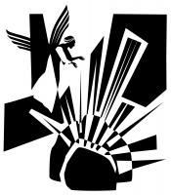

Fifteenth Station:

Jesus risen from the dead

Fifteenth Station: Jesus risen from the dead

We adore you, O Christ, and we bless you,
Because by your holy cross
You have redeemed the world.

Reading

When they looked up, they saw that the stone, which was very large, had already been rolled back. As they entered the tomb, they saw a young man, dressed in a white robe, sitting on the right side; and they were alarmed. But he said to them, ‘Do not be alarmed; you are looking for Jesus of Nazareth, who was crucified. He has been raised; he is not here. Look, there is the place they laid him. But go, tell his disciples and Peter that he is going ahead of you to Galilee; there you will see him, just as he told you.’ So, they went out and fled from the tomb, for terror and amazement had seized them; and they said nothing to anyone, for they were afraid.
Mark 16.4-8

Reflection
There will you see him
I, too, met him on the road, only years later. At a time, I was one of those who said I needed to see where the ails had been in order to believe.
Yes, I heard the stories that spread like wildfire through dry grass that Sunday morning: the women who went to the tomb and found it empty; the stone rolled away; and Mary, weeping in the garden, finding him alongside her; and the other two that evening having their journey turned around when he broke bread with them;
continued….
and all of them, all that troubles, motley band of clumsy and confused apostles sheltering in the upper room for fear that what happened to him might happen to them, seeing him, eating with him, listening to him, finding that it was not over, that it was only just beginning.
But not me.
I had always been on the edge, always skulled in the shadows. And that’s where I stayed. I was frightened of walking away from him completely, but also frightened of following him. I just kept looking at the cross, but I couldn’t pick it up.
Then one day, all that changed.
Did I say I met him on the road? No, it wasn’t like that. He found me, and when he did, there was such a smile on his face. He said with earnest joy, that I was the one he had been looking for.

Prayer
Lord Jesus, you were dead but now you are alive; transform the torments of this world’s sin that we may see your radiant glory. You were raised from the death to life: may the power of your resurrection live in us, that we may be channels of your true life beyond measure. To you, Jesus, who have broken free from the bonds of death, be honour and glory with the father and the Holy Spirit, now and forever. Amen.
Holy God,
Holy and strong,
Holy and immortal,
Have mercy upon us.

The Conclusion

Prayer
Let us pray for the coming of God’s kingdom the words our saviour taught us.

Our Father, who art in heaven,
hallowed be thy name;
thy kingdom come;
thy will be done;
on earth as it is in heaven.
Give us this day our daily bread.
And forgive us our trespasses,
as we forgive those who trespass against us.
And lead us not into temptation.
but deliver us from evil.
For thine is the kingdom,
the power and the glory,
for ever and ever.
Amen.

Our Father in heaven,
hallowed be your name,
your kingdom come,
your will be done,
on earth as in heaven.
Give us today our daily bread.
Forgive us our sins
as we forgive those who sin against us.
Lead us not into temptation
but deliver us from evil.
For the kingdom, the power,
and the glory are yours
now and forever.
Amen.
Most merciful God,
who by the death and resurrection of your Son Jesus Christ
delivered and saved the world;
grant that by faith in him who suffered on the cross
we may triumph in the power of his victory;
through Jesus Christ you Son our Lord,
who is alive and reigns with you,
in the unity of the Spirit,
One God, now and forever. Amen

We adore you, O Christ, we bless you,
because by your holy cross
you have redeemed the world.

Christ manifested in the body,
vindicated in the spirit,
seen by angels,
proclaimed among the nations,
believed in throughout the world,
glorified in high heaven.

We adore you, O Christ, we bless you,
because by your holy cross
you have redeemed the world.

The Lord be with you
and also, with you.

May God Bless you,
that in us may be found love and humility,
Obedience and thanksgiving,
discipline, gentleness and peace.
Amen.

Contact Details:

All Saints’ Parish Church, Streetly
Foley Road East
Sutton Coldfield
West Midlands
B74 3JL

Tel. No.: 0121 353 3582
Email: allsaintstreetly@btinternet.com

(Charity Number 1134127)

Adapted for use from words written by Bishop Stephen Cottrell,
illustrations by Nicholas Markell
Church House Publishing 2019, London

