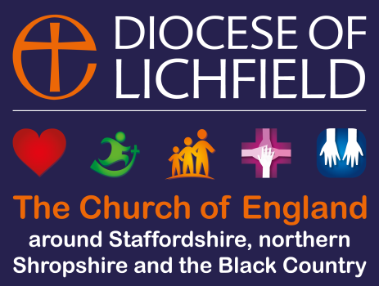
The Diocese of Lichfield (LDBF/LDBE)
St Mary’s House
The Close
Lichfield WS13 7LD

Insert parish name/logo here & office contact details

Media Consent Form
In celebrating, remembering and telling the stories of our churches, schools and associated groups and events, it is invaluable to use:
- photos,  - video and  - audio | in our | - print publications,  - website and  - social media | and sometimes those of | our related organisations:  - local church/school,  - Lichfield Cathedral,  - the national Church of England or  - local and national media.
We ask for your agreement that you/your child’s image/voice may be featured while participating in activities organised by the Diocese of Lichfield, our Parishes, Schools, and other associated organisations.

Conditions of use:
- We may include details such as names or affiliated organisation when context requires it.
- We will always follow Diocese of Lichfield guidelines and policies relating to Safeguarding and Social Media., available at http://www.lichfield.anglican.org/social_media/
- We may share photos/video with our partners, Parish churches, Lichfield Cathedral, the national Church of England and local/national media. Please be aware that websites and social media can be seen throughout the world and not just in the United Kingdom, where UK law applies.

I have read, understood and agree to the Conditions of Use.

Name in block capitals:........................................................................................................
Signature (if aged 13 or over) Date:
………………………………………………………………………………………………………………………… ……………………………………………………………...
Signature of parent/guardian (if aged 16 or under) Date:
………………………………………………………………………………………………………………………… ……………………………………………………………...
Email (or address) Date of Birth (if aged 16 or under)
………………………………………………………………………………………………………………………… ……………………………………………………………...
Please return this form to the event organiser or photographer or email to comms@lichfield.anglican.org

